Elizabeth I’s Reign
A Virtual Tour

The Beauchamp Tower
TOWER OF LONDON

NAME: __________________________________________
1 | Outside | Building Features
1. Have a look at this map from 1597. Where is the Beauchamp Tower? HINT: The Beauchamp Tower is part of the west inner curtain wall
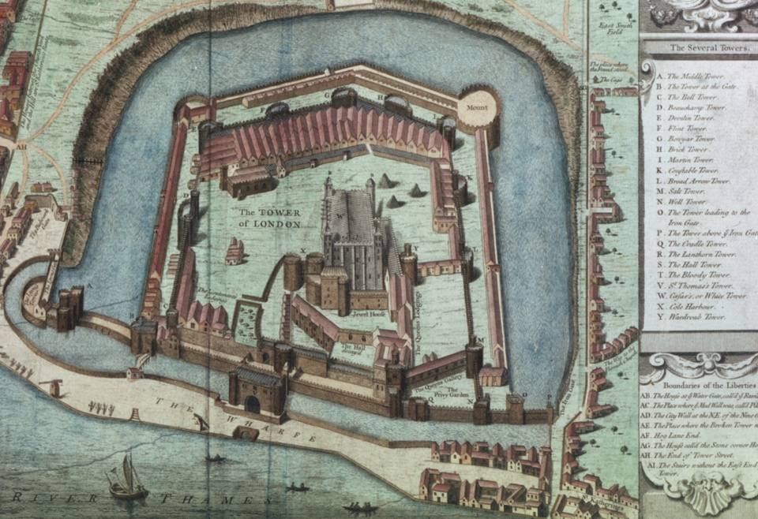
2. What different uses has the Beauchamp Tower had?

3. How might the design and location of the Beauchamp Tower have made it useful to Elizabeth I as a prison?


2 | Ground Floor | Tudor Crime
1. Apart from Elizabeth I, which other Tudor monarchs might have imprisoned people here?
2. Which plots or rebellions might have led to people being imprisoned in the Beauchamp Tower?
HINT: There’s a lot of evidence of prisoners from the 1570s
3. People where held here on charges of ‘treason’ and ‘heresy’. What is the difference between ‘treason’ and ‘heresy’?
Ground Floor | Tudor Punishment
The graph on page 3 shows the number of people imprisoned at the Tower of London between 1483 and 1603.

Identify areas on the graph where there were lots of prisoners.

What events took place around these times that might have led to a high number of prisoners?
Label the key episodes of unrest during the reign of Elizabeth I.
3 | Prisoners at the Tower of London
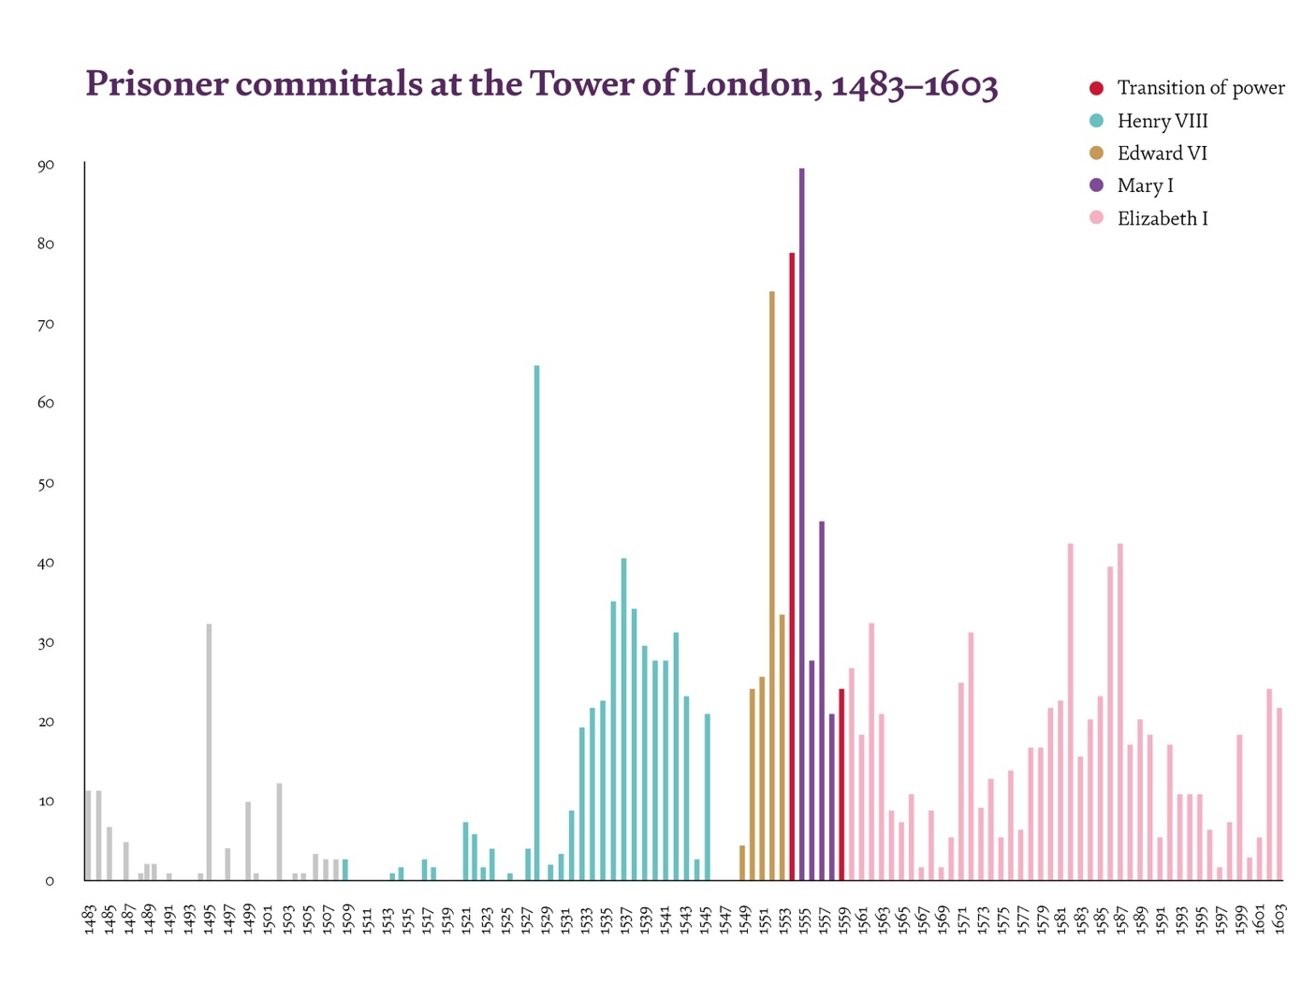

4 | Staircase | Religious Rollercoaster
1. What religion were each of these Tudor monarchs?

Henry VIII ____________________ reigned 1509-1547

Edward VI ____________________ reigned 1547-1553

Mary I ____________________ reigned 1553-1558

Elizabeth I ____________________ reigned 1558-1603

2. Create a timeline of the Tudor monarchs’ reigns. Make your timeline rollercoaster shaped to show the different monarchs’ religions.

5 | First Floor | Prisoners’ Graffiti
1. Look closely at the graffiti. Are there any common themes, images or words?
2. What clues are there about what types of people were held here?
3. Do you think they were mostly traitors or heretics? Why?

4. Are there any pieces of graffiti that have a date linked to any of the events you labelled on the graph on page 3? If so, use one of these for the next task.
5. Choose one prisoner to research and find out more about.
• Where in the country did they live?
• How did they come to be a prisoner at the Tower of London?
• What happened to them in the end?

Remember: The Tudor monarchs used the Tower of London to silence many people. By researching their stories, you are helping to give them back their voices.
6 |  | Prisoner Research
 | 


7 | First Floor | Protestant Prisoners
Take a closer look at the ‘Jane’ and ‘Dudley’ carvings. Think about:
- How might they have been created?
- Who might have carved them?
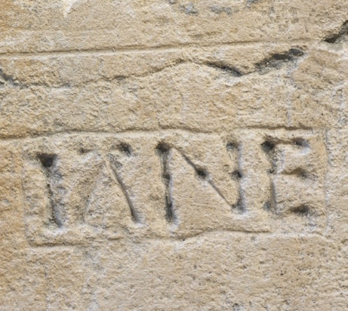 |  | 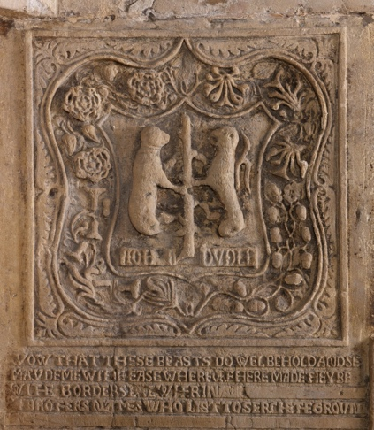
1. What is similar about them?

2. What is different about them?

8 | First Floor | Catholic Prisoner
1. How might Elizabeth I have felt about the Tower of London?

Look closely at the Philip Howard (Earl of Arundel) carving.
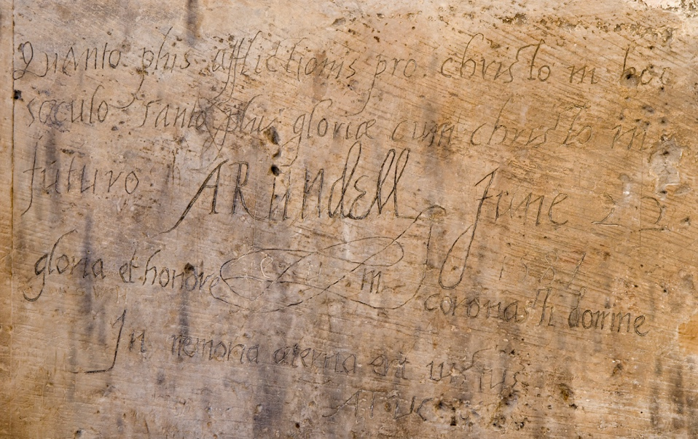
2. What words do you recognise?

3. Read or listen to the translation of the carving. What do you think Philip Howard meant by these words?


9 Timeline & Interpretation
1. Use the next page to create a timeline from 1550 – 1603.
In one colour, add key events from Elizabeth I’s reign. In a second colour, add key events, prisoners, or evidence linked to the Beauchamp Tower. You may wish to include:
- the Elizabethan Religious Settlement (1559)
- Papal excommunication (1570)
- major plots and rebellions
- named prisoners and dated graffiti from the Beauchamp Tower

Final question
How and why did Elizabeth I use the Beauchamp Tower during her reign? Use evidence from your timeline and the prisoners’ graffiti to support your answer.

10 Timeline

Instructions
Use this student booklet alongside the interactive Elizabeth I virtual tour for KS4 and KS5. To print as an A4 booklet:

- Go to File > Print.
- Select your printer and set it to:
Print on Both Sides (flip on short edge).
- In printer options or printer set up choose:
landscape and A4.
- Check for any scaling options and set them to: 100% or Actual Size. This may also need to be done in File > Options > Advanced > Print > Deselect: “Scale content for A4”
Answers (teacher can delete)
Building Features 2. Defence, prison, visitor attraction, home 3. The Beauchamp Tower’s strong stone design and position within the inner defences, close to the River Thames, made it easy to guard prisoners, control access, and move high status captives securely, reinforcing Tudor authority.

Tudor Crime and Punishment 1. Henry VIII, Edward VI and Mary I. 2. The Ridolfi Plot 3. Treason was acting against the monarch or the state, while heresy was holding or spreading religious beliefs that went against the official Church. 4. Students might include the Northern Rebellion, The Ridolfi Plot, The Babington Plot, Execution of Mary Queen of Scots, Spanish Armada.

Religious Rollercoaster 1. Henry VIII was Catholic (however he started a more Protestant church in England as part of the Reformation). Edward VI was Protestant. Mary I was a strict Catholic. Elizabeth I was Protestant.
Prisoners’ graffiti 1. Common themes include religion (crosses), dates, names, symbols including flowers and skulls. 2. The graffiti suggests that many prisoners were educated and high‑status, such as nobles or gentlemen, because they could write clearly and included family symbols and meaningful messages. 3. They were likely mostly heretics, because much of the graffiti focuses on religion and faith, showing that many were imprisoned for their religious beliefs rather than for directly plotting against the monarch.

Protestant Prisoners 1. Both feature names of people held at the Tower. They were probably made around a similar time. 2. The Dudley carving is very elaborate and might have been carved by an expert using special tools. It has symbols and a coat of arms and is near the fireplace. The Jane carving is very simple and plain and was likely carved by a prisoner. It is near the window.
Catholic Prisoners 1. Elizabeth I likely had conflicting feelings about the Tower of London: she disliked it because her mother was executed there and she had been imprisoned there as a young woman, but she still used it as a necessary symbol of royal power and control to protect her reign. 2. Christo/Christ, Gloriea/Glory, Honore/Honour. 2. The carving is about the prisoner’s faith. 3. Philip Arundel’s carving suggested he believed that the more pain he experienced in God’s name whilst he was alive, the more happiness (glory) he would get in another life.

Final question Elizabeth I used the Beauchamp Tower as a secure prison to control and contain religious and political threats without always resorting to execution. Following events shown on the timeline, such as the Elizabethan Religious Settlement and the Papal excommunication of 1570, Catholics were seen as a growing danger, which led to the imprisonment of figures like Philip Howard. The prisoners’ graffiti reveals strong religious beliefs, loyalty, and suffering, showing that many were held for their faith rather than direct rebellion. This evidence demonstrates how Elizabeth used imprisonment in the Beauchamp Tower as a preventative measure to maintain stability and protect her authority during her reign.


