Front cover


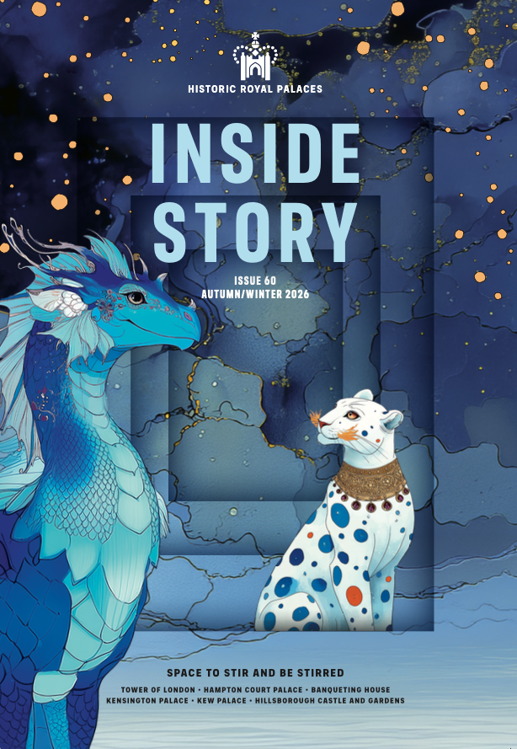

Inside Story
  - Issue 60 | Winter 2026
Inside front cover

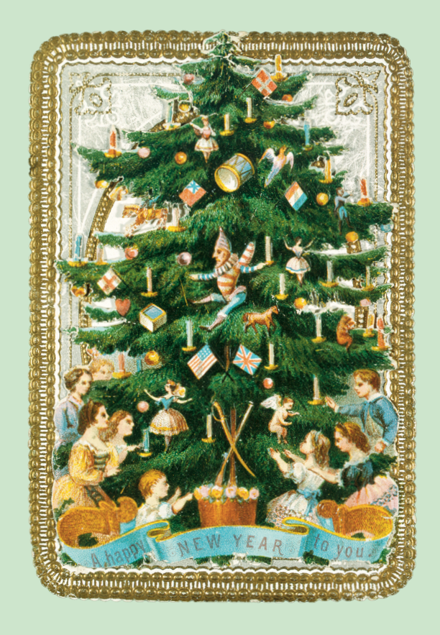

welcome…


… to our autumn/winter issue.

As a new series of BBC One’s ‘Celebrity Traitors’ hits our small screens,
we couldn’t resist sharing some dark histories of our own palace-related villains – or were some of them actually faithful? You decide (page 22)!

We’re celebrating the spooky season with Halloween howls, hauntings and lots of family fun at all the palaces. Ghouls are gathering at Hampton Court – are you brave enough to meet them (page 16)? I got goosebumps just reading about the Georgian ‘true ghost’ sighting, unearthed from newspaper archives (page 15).

It’s going to be a magical Christmas at the palaces! Join us at the Winter Beast Ball as Hampton Court is transformed into a gorgeous Winter Palace (page 30). Discover how Victorian visitors and residents had surprisingly festive fun at the Tower (page 36) and why a trip to the ballet left Princess Victoria star-struck (page 46).

In ‘On the spot’ (page 52) Chief Executive John Barnes describes how your support is crucial to the work of our charity. Make your membership donation go 25% further by opting in to Gift Aid. See details on the right. Enjoy the season!

Angie Faires
Head of Marketing and Membership
GIFT AID YOUR MEMBERSHIP AT NO EXTRA COST
Historic Royal Palaces is an independent charity, and we rely
on your support to continue to preserve the magnificent palaces and gardens in our care.

You can make your membership donation go 25% further at no extra cost to you by opting in to Gift Aid. If you’re a UK tax payer, please email us at members@hrp.org.uk, and we can claim an extra 25p per £1 of your membership fee from the government. Opt-in today to help us transform tomorrow.

Published by Historic Royal Palaces, Hampton Court Palace, Surrey, KT8 9AU.

In-house editor: Clare Murphy
External editor: Sarah Kilby

© Historic Royal Palaces 2026. All rights reserved. No part of this publication may be reproduced or transmitted in any form or by any means, electronic or mechanical, including photocopying, recording or any information storage or retrieval system, without permission in writing from the publisher.

Unless otherwise stated, all images are © Historic Royal Palaces.
Historic Royal Palaces is a registered charity (No 1068852)
Contact us: insidestory@hrp.org.uk

What’s Inside
Issue 60

Making the most of your membership 7
DATES FOR YOUR DIARY 11
News 17
MEMBERS’ PHOTOS 27
Hooray for Halloween! 31
SCREEN STAR 38
Curators pick traitors! 43
THE FESTIVE FORTRESS 69
ON THIS DAY 77
KENSINGTON’S STARSTRUCK PRINCESS 84
BIG ADVENTURES FOR YOUNG EXPLORERS 89
JOHN BARNES 95

Making the most of your membership
Tips to help you enjoy your membership, at our palaces and gardens, and at home
See for free
Planning your free visit
As a member, you can enjoy free, unlimited entry to some of the UK’s most iconic palaces: Tower of London, Hampton Court Palace, Kensington Palace and Hillsborough Castle and Gardens, as many times as you like.

You only need to pre-book free tickets on select event days; at all other times, simply show your membership card. Visit hrp.org.uk and search What’s On for opening hours and booking requirements.

If you need help planning your visit or booking member tickets online, you’ll find answers to common questions in our membership FAQs at hrp.org.uk.

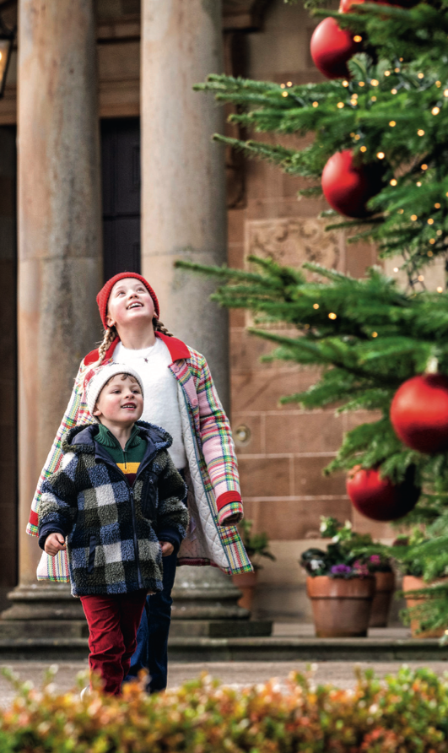

Discover more
Unmissable events

As a member, you benefit from free or discounted entry to a wide range of events including special exhibitions, festivals and fayres. Plus, an exclusive programme of members-only tours, talks, and behind-the-scenes experiences throughout the year.

Visit hrp.org.uk/whats-on-all-the-palaces to see what’s on and whether you need to pre-book.

Save more
Great savings
Bring your membership card on every visit to enjoy 10% off* in our shops and cafés, plus 10% off* in our online shop with code MEMBER26. Black Friday: members enjoy 20% off in shops
27–30 November*. Pick up a Member Royal Reward Card in one of our on-site cafés to collect stamps and get your 6th hot drink free!
*Exclusions may apply.

Discover more
explore the vault

Unlock behind-the-scenes digital content, curated especially for members, on your digital hub. Get closer to the palaces and our history through expert interviews, thought-provoking podcasts, videos and fun family activities.

Stay in touch

We’ll let you know about the latest member exclusives, events, early ticket releases and discounts in regular member email newsletters.

Email: members@hrp.org.uk to update your details or contact preferences, or to ask us a question

Visit: hrp.org.uk for …
• Opening days and times
• Access information
• Things to see and do
• More about our buildings and collections

Use: your Member login to ...
• Manage your account and password
• Upgrade or renew your membership
• Book tickets

Follow: Historic Royal Palaces on Instagram, Facebook and X
We’d love to see how you’re making the most of your membership! Post your photos with #PalacePhoto.

DATES FOR YOUR DIARY
hampton court palace
Explore Henry VIII’s notoriously haunted residence at Halloween at Hampton Court Palace, 24 October – 01 November. Be enthralled by atmospheric projections, eerie sound effects and magical spells. Will you spot our famous ghosts haunting the halls?

Don’t miss the return of the Festive Fayre across two magical weekends, 04 – 06 and 11 – 13 December, hosted entirely in the Great Fountain Garden. Browse over a hundred independent artisan stalls for special gifts. Enjoy merry music from the bandstand, festive treats and delicious street food.

NEW to our festivities is Winter Palace: The Christmas Beast Ball, 28 November – 03 January – a visit could start an annual family tradition. Step inside the glowing halls of the palace and meet mythical beasts at the most enchanting ball of the year.

tower of london
Encounter ghosts connected to the Tower’s history at Halloween
at the Tower of London, 24 October – 01 November. Immerse yourself in the eerie sights and sounds as you weave your way along cobbled paths and battlements exploring 1,000 years of history.

This year at the Tower of London, experience Victorian Traditions at Christmas with our festive displays, 27 November – 03 January. From gift giving to Christmas trees and cards, explore how the familiar Christmas celebrations of today were made popular by the Victorians.

Be part of an ancient tradition with a members-only opportunity to witness the Ceremony of the Keys, held nightly for over 700 years (separate ticket, pre-booking required).

Embark on a voyage aboard the official Tower of London River Tour and experience London’s iconic landmarks. Members enjoy 50% off using code HRPMEMBERS50. Book online at hrp.org.uk. Exclusions apply.
Member event highlights
• Members-Only Carol Service, Chapel Royal, Hampton Court Palace; 09 and 14 December. Tickets on sale 04 November.
• Members-Only Carol Service, St Peter ad Vincula, Tower of London; 15 December. Tickets on sale 04 November.
• Members-Only Christmas Dinner and Shopping evening, Hillsborough Castle and Gardens; 03 December. Booking now.

book now
Pre-booking via your Member login is required during select events; look out for the ticket icon. Many events are included in palace admission; some require separate event tickets.
See hrp.org.uk and check
What’s On for details.

book now
Pre-booking via your Member login is required during select events; look out for the ticket icon. Many events are included in palace admission; some require separate event tickets.
See hrp.org.uk and check
What’s On for details.

book now
Pre-booking via your Member login is required during select events; look out for the ticket icon. Many events are included in palace admission; some require separate event tickets. See hrp.org.uk and check What’s On for details.

Hillsborough Castle and Gardens
This October half term, 24 October – 01 November, gather your little witches, wizards and adventurers for a spellbinding day out at Halloween at Hillsborough Castle and Gardens. Follow a whimsical trail to help a crash-landed witch find the perfect broomstick and enjoy outdoor workshops, magical storytelling and classic autumn games.

The annual Scarecrow Parade returns 10 October – 08 November. See the Walled Garden vividly brought to life with spectacular scarecrows.

This festive season, step into the magical world of The Gruffalo’s Child on an enchanting daytime trail through the gardens, 28 November – 03 January (excluding 24-26 December). Discover favourite scenes from the much-loved story and on select dates, meet the Gruffalo or Santa and watch The Gruffalo’s Child film.
At a glance
• The Scarecrow Parade
10 October – 08 November

• Halloween at Hillsborough Castle and Gardens
24 October – 01 November

• Meet Santa
Select dates in November and December. Members enjoy discounted tickets, £7
• Christmas at Hillsborough Castle and Gardens
28 November – 03 January (excluding 24 – 26 December)

• Meet the Gruffalo
27 December – 03 January. Members enjoy discounted tickets, £6

• ‘Royal Style in the Making’
Until 03 January 2027

Until 03 January 2027

Kensington Palace
In the winter of 1836, Princess Victoria spent Christmas at the idyllic Claremont House in Surrey. Marking 190 years since her countryside festivities, join us for Victoria’s Countryside Christmas, 25 November – 03 January, to see decorations and displays evoking the magic, intimacy and charm of her seasonal retreat.

Next year’s looking special ... From spring 2027, the Queen’s State Apartments at Kensington Palace will be re-presented to reveal the life of Mary II, offering visitors the chance to step back in time in her rooms and experience her world. Exclusively for 2027, a temporary immersive display will explore Mary’s inner world, personal writings, and female friendships.

At a glance
• Halloween at Hampton Court Palace
24 October – 01 November
• Halloween at the Tower of London
24 October – 01 November
• ‘The Last Princesses of Punjab’ at Kensington Palace
Until 08 November
• Hampton Court Palace Ice Rink
20 November – 03 January (excluding Christmas Day).
Save 10% or more. Use codes HRPMEM15OP (off-peak); HRPMEM10P (peak); HRPMEMFAMILY15 (Family off-peak).
• Victoria’s Countryside Christmas at Kensington Palace
25 November – 03 January
• Victorian Traditions at Christmas at the Tower of London
27 November – 03 January
• Winter Palace at Hampton Court Palace
28 November – 03 January
• Hampton Court Palace Festive Fayre
04 – 06 and 11 – 13 December

News

News
Every issue, we bring you the latest developments from across the palaces
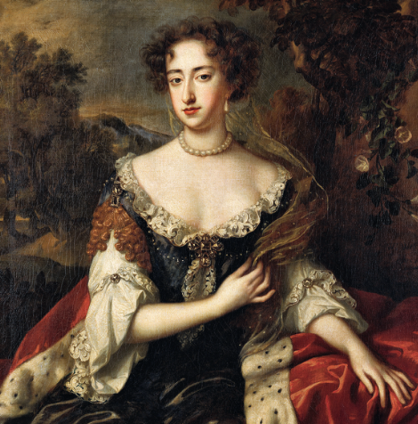

FIT FOR A QUEEN

In spring 2027, the Queen’s State Apartments at Kensington Palace will re-open after a huge transformation.

Our curators have undertaken intensive research to understand exactly how Queen Mary II (1689-94) presented and used these rooms during her life. The redisplay will reflect Mary’s extravagant tastes in home décor, furniture and furnishings. It will also narrate the story of the largely forgotten queen, who came to power in a coup d’etat against her own father during the event known as the ‘Glorious Revolution’. (See ‘Curators pick Traitors!’ page 22.)

We have also been working with local community groups to create works of art inspired by Mary’s story and their own experiences. These will be displayed along the route, where you will also hear whispers of court gossip, stories of servants and ladies, and announcements of crucial governmental decisions that changed the way the monarchy and parliament function today.

Mary grew up in the English court and then, after marrying William III, travelled overseas to the Dutch House of Orange. The newly renovated rooms will reflect the cross-cultural connections between the two royal courts. You can expect masses of East Asian porcelain, sumptuous new hangings and some sparkly new objects previously belonging to Mary and William.

Mary lived and died in Kensington Palace – this redisplay will mark her short but impactful reign and will be accompanied by a temporary immersive display in the Pigott Galleries, which explores the woman behind the queen. Find out more in our next issue! New research for the displays has been supported by Graham and Joanna Barker.



A sunny welcome at the palaces

As part of our ongoing commitment to improve inclusion, we are proud to announce that Historic Royal Palaces has joined the global Hidden Disabilities Sunflower.

Throughout the world, one in six of us live with a disability and while some are visible, many are not. The Hidden Disabilities Sunflower is a simple tool for people to signal, discreetly that they have a disability or condition that may not be immediately apparent – and that they may need a helping hand, more time or understanding during their visit. All our front-of-house staff have been trained to recognise the Sunflower lanyard or card and provide assistance when needed. To find out more about the Sunflower visit hdsunflower.com

a royal obsession

Young Queen Victoria’s favourite ballerina has taken centre stage in a new dance-themed display at Kensington Palace.

Marie Taglioni is often regarded as the most famous and talented ballerina of the 19th century. Among her fans, she counted the Empress of Russia and Princess Victoria, the future queen (see page 46). As part of our permanent exhibition ‘Victoria: A Royal Childhood’, rare surviving objects from Taglioni’s personal collection have recently gone on display at Kensington. On loan from the Victoria and Albert Museum, they include Taglioni’s ballet slippers, which are made of fine black satin. The simplicity of their design, with none of the stiff toe support of modern versions, makes it possible to appreciate Taglioni’s exceptional skill in dancing en pointe — on the tips of her toes — a technique that so enchanted Princess Victoria. These special objects will be on display until April 2027.
SEE FOR FREE
Step into Queen Victoria’s childhood home and uncover the royal passion for ballet at Kensington Palace.
No pre-booking required.

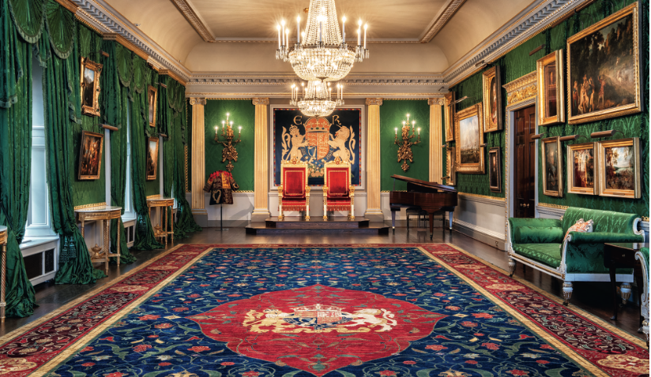

woven tales

After three years in the design and making, a spectacular new carpet has recently been installed in the Throne Room at Hillsborough Castle, transforming both the room and the lives of those who created the carpet.

The carpet was made in collaboration with Turquoise Mountain, the charity founded in 2006 by King Charles III, which works to revive historic crafts and create jobs and skills, helping to sustain both communities and traditions. It was woven in northern Afghanistan, where a special loom had to be constructed in a new building – at 15 x 6 metres this is the largest carpet Turquoise Mountain have ever made. Production took more than a year, starting with the harvesting of wool from 160 Ghazni sheep. Then, 38 weavers worked on the carpet, with ten weavers working side by side at any one time, creating about 4cm of carpet a day. The commission provided vital income for the families of those involved and supported around 100 people across the process, from wool spinners and dyers to washers and finishers.

Although the carpet is traditional in its historic Persian medallion design, it includes many elements inspired by Hillsborough Castle and its gardens – pears nod to the walled garden, while pineapples reference the lost pineapple house. Continuing a long tradition of carpets commissioned by royal patrons, our carpet features the Royal Arms in the centre of the medallion, reflecting the heraldic banner in the Throne Room.

We are grateful to The Drapers’ Company for supporting the creation
of the carpet and for their ongoing support of the schools’ programme at Hillsborough Castle and Gardens.

Earth to ashes – an Elizabethan mystery

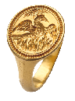

Elizabeth I’s extraordinary story – the daughter of Anne Boleyn, who was betrayed and executed by her own father, Henry VIII and yet survived to become England’s first sovereign queen – inspired poets and artists to celebrate her prosperous reign. Her life is encapsulated in this gold signet ring, now on display at Hampton Court, which Elizabeth frequently visited about the time it was fashioned by an unknown goldsmith.
Its minute engraving shows a phoenix rising from the ashes of a fire towards the sun, that unique mythical bird that dies in flames, only to be reborn again. In the 1570s the obscure poet Ulpian Fulwell started a craze at court to compare Elizabeth and her mother, Anne, to the indestructible phoenix. Even Shakespeare wrote a more memorable poem in her later years, called the ‘Phoenix and the Turtle’ (dove) and the artist Nicholas Hilliard famously portrayed the Queen wearing a phoenix jewel.

The newly acquired ring is something of a puzzle, as it was handed in by a metal detectorist to be saved for the nation under the Treasure Act. Despite its small size, it was probably owned by a gentleman supporter of Elizabeth, who either lost or hid it in the royal hunting ground of Ampthill in Bedfordshire. Elizabeth herself visited this royal castle at least once, under the stewardship of her loyal cousin, Henry Carey.

We are grateful to the Meakins Family for generously supporting this purchase and to the Portable Antiquities office at the British Museum for their expert assistance.

DISCOVER MORE
Visit hrp.org.uk and search ‘Elizabeth I, the Last Tudor’, or browse ‘History and Stories’ to follow Elizabeth’s path from Tower prisoner to English queen.

Top of the class!


Huge congratulations to Elizabeth Carr from Avanti Grange Secondary School in Bishop’s Stortford, the overall winner of our inaugural Inspiring History Teaching Awards, celebrating teachers who bring the past to life in classrooms across the UK. Ten winners were selected from thousands of nominations submitted by pupils, parents and colleagues with the overall winner being announced at an awards ceremony and dinner at the Tower of London in June. Elizabeth Carr stood out to judges for her ability to combine academic rigour with creativity and inclusivity. She built her school’s history curriculum from the ground up, encouraging students to think critically, ask questions and engage deeply with the past. You can find out more about all ten winners at hrp.org.uk/teachingawards Nominations for the 2028 competition open in 2027. Who will you nominate?

streaming now

Tune into our podcast ‘Charles I – The Execution of a ‘Traitor’ King at the Banqueting House’. Join curators at the site of Charles I’s execution, before moving to Hampton Court to discover the surprising way that Oliver Cromwell used the palace. As we approach the millennium anniversary of William the Conqueror’s birth in 2027, don’t miss our Norman series including Tower of London myth-busting, and the women who are often left out of the story.

MEMBERS’ PHOTOS
LOUDER THAN WORDS…
At the start of this year, as we celebrated 20 years of Historic Royal Palaces membership, we asked you to share your favourite moments at the palaces – in pictures! We’ve had hundreds of responses, and we enjoyed seeing them all; here are just a few of our favourites. Thank you to everyone who sent in such lovely photographs capturing the memories that make membership so special.

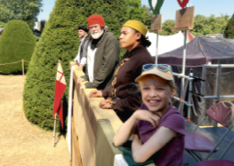
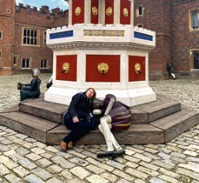

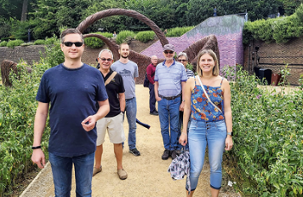
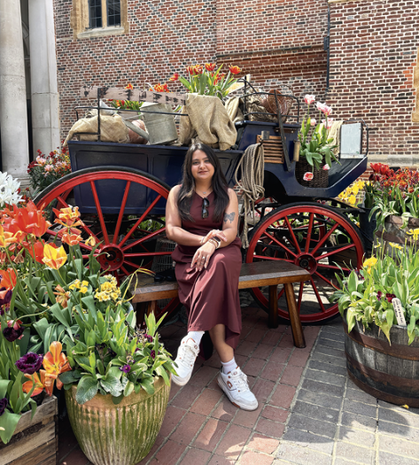
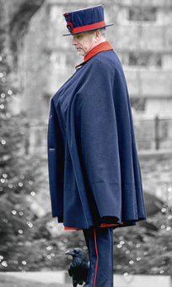

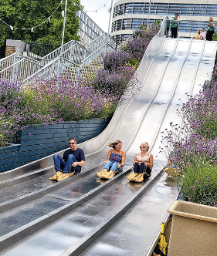
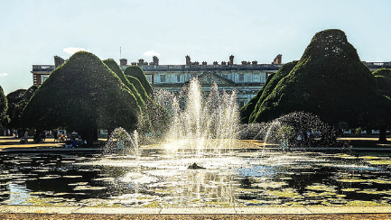
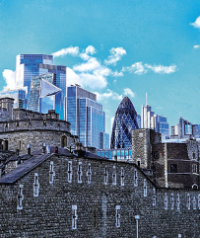
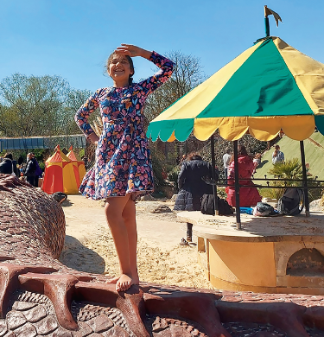
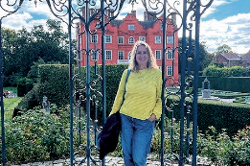


Keep the memories coming
Follow Historic Royal Palaces on Instagram, Facebook and X, and post your photos using #PalacePhoto

THANK YOU
For two decades, your support has helped us open up our palaces and share their remarkable stories. Turn to page 52 to hear from Chief Executive John Barnes about the difference members continue to make.

HALLOWEEN

Hooray for Halloween!
It’s all howls and hauntings at Hampton Court Palace this year, as Halloween fun begins! We’re telling spooky stories, summoning up spectres and the palace itself is dressed to kill. Join us – if you dare!

Throughout October, a visit to the palace will be truly terrifying, as we celebrate all that is weird and wonderful in Hampton Court’s history. Will you be brave enough to explore the terror-ific transformations? You won’t want to miss out on the occult marketplace in Master Carpenter’s Court, a mad scientist’s laboratory
in the Clerk’s Office, ectoplasm climbing the walls of the Wine
Cellar, and a rancid, rattling feast in the King’s Private Dining Room (not for the squeamish)…

A Georgian ghoul
To get those goosebumps going, here’s something strange that was recently unearthed by our Historic Buildings Curator, Karey Draper. While searching through newspaper archives, a peculiar letter to The Morning Chronicle, dated 16 September 1777 caught her eye. This is one of the earliest ghost sightings we have ever come across, and we’re thrilled to share it with you here!

Are you brave enough to greet our ghosts? A scary selection of characters from Hampton Court’s past will be drifting through the palace at half-term, mysteriously drawn to a gathering in Base Court and Clock Court twice a day. They’re longing to meet you! Just in case you are struck speechless with terror, here’s an introduction to just a few of them …

Michael Faraday
The ground-breaking scientist lived in a grace-and-favour residence situated on Hampton Court Road (opposite Trophy Gate) until his death in 1867. Among other things, he discovered how to generate electricity, so no doubt he’s got a few shocks in store for you!

Ernest Shackleton
Following his death during an expedition to the Antarctic in 1922, Shackleton was buried in South Georgia. His wife Emily was left with considerable debts, and she was granted a grace-and-favour home near the Tudor Kitchens. After a long illness, she died in 1936. Has the famous explorer returned from his icy grave to find her, a century too late?

Ada Goodrich-Freer
A ghost-finder extraordinaire! Ada described many ghoulish glimpses at the palace in The Victorian Ghost Hunter’s Casebook, from the 1900s. She loved the legends surrounding Henry VIII and the reported hauntings of his queens Jane Seymour and Catherine Howard. Will Ada’s spectral presence rouse any other sleeping spirits to join her?

Harry Corant
A 16th-century English woodcarver, who sculpted the original King’s Beasts for Henry VIII. He appears clutching his favourite, the mischievous yale with swivelling horns and a lion’s tail. Has he come back to revenge the destruction of his sculptures by William III in the 17th century?

Jacques Francis
The expert African free diver led the expedition to salvage King Henry VIII’s guns from the warship Mary Rose after it sank within minutes of leaving dock in 1545. Is Jacques Francis now looking for King Henry VIII to give him back his lost treasures?

Sir,
For some month past the inhabitants of Hampton Court have been amused with stories of strange noises having been heard during the night in many of the courts and passages; and some went so far as to aver their having seen an uncommon figure stalking through the dark passage which leads to the chapel.
This, however, by people of sense, was laughed at as chimerical, ‘till, on Tuesday evening last, a gentleman of undoubted veracity (who has far too much firmness and good sense to be imposed on by an illusion of fancy) returning from a visit through the above passage, was surprised by hearing a hollow murmur, like the sound which generally proceeds a storm, or a deep groan, mellow’d as it were by being heard at some distance: this was immediately succeeded by a faint light, which slowly approached him.
The gentleman had a stout cane in his hand, and imagining this to be some disguise to frighten him, was determined to give the author of the farce a wholesome correction. No sooner therefore was the figure within his reach, than he struck at it with all his might, and to his astonishment the end of the stick fell to the ground as if nothing opposed it: he had the courage, however, to strike again, and fully convinced himself that the figure had no bodily existence. He confessed he was then very much startled, but still preserved firmness enough to question it; it returned no answer, but, gliding as it were slowly back to the chapel door, beckon’d him to follow.
This (as he thought it might possibly be a spirit of evil) he declined, and made the best of his way home.

I am Sir, your humble servant,
Prospero

see for FREE
Dare to face the spirits that roam from 24 October to
01 November; no pre-booking required. Designed to be family-friendly, but expect darkness, loud noises, flashing lights and occasional jump scares.

hosting halloween

Take a seat as the spooky season gets under way with our series of Palace Host Talks, presented by our expert storytellers in the Stone Room in William III’s Apartments. Enjoy a 15-minute terrifying tale from Hampton Court’s history, suitably scary for Halloween. Topics include our famous ghost stories, witchcraft and witch trials of James I, and the dark side of being a queen, featuring Elizabeth I, Mary Queen of Scots and Lady Jane Grey.

• 01 – 23 October
• 11.30 and 14.30, Wednesday – Sunday
• Members go free; no pre-booking required.
• For more information search Palace Host Talks on hrp.org.uk
Eeek! What a wicked week!
Halloween happenings over half term
Spooky storytelling
This fictional tale features lots of audience participation. It’s not too scary for younger visitors, but may be adapted for an older, bolder crowd, too! Enter a darkened King’s Guard Chamber, with candlelight illuminating the giant statues and deadly weapons on display. Prepare for a scare!
• 24 October – 01 November
• 15-minute sessions throughout the day, see hrp.org.uk for details.
• Members go free; no pre-booking required.
WIN!
We have 15 copies of Murder at the Tower by N R Daws to give away to members. To enter, email insidestory@hrp.org.uk by 11 November 2026 and tell us the name ofthe African free diver you might encounter at Hampton Court this Halloween. Winners will be chosen at random and notified by email by 27 November 2026. Full terms and conditions: hrp.org.uk/membership/ tower/competition

DISCOVER MORE
The spooky season continues across our palaces. Turn to page
06 for the Tower of London’s ghostly goings-on, or page 50
for a spellbinding family adventure at Hillsborough Castle and Gardens.

CONSERVATION

SCREEN STAR
Little is known about the life of Jean Tijou, but the ornate ironwork at Hampton Court Palace is testament to his genius. This mysterious metalworker also created a challenge for conservators, as Dan Jackson, Head of Historic Buildings, explains

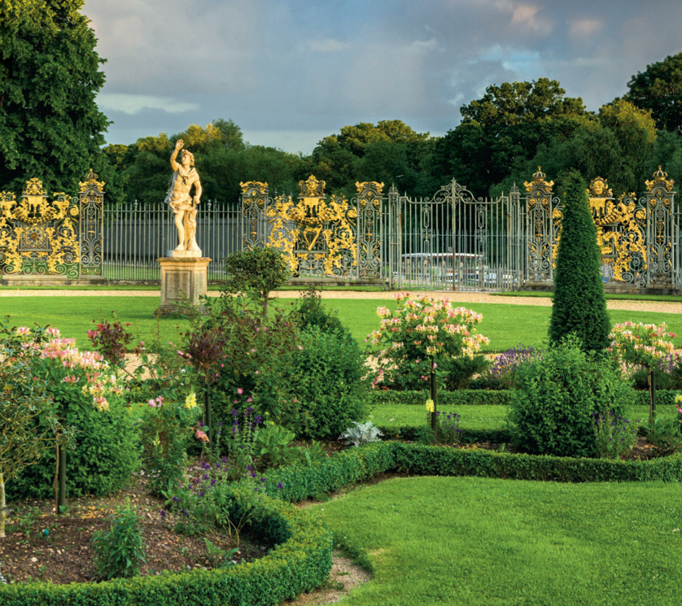
Down by the riverside at Hampton Court, amid the birds and bees, stands the magnificent metalwork of the Tijou Screen.

Any visitor to the palace, or passerby enjoying the walk along the Thames, will have had the opportunity to see one of the finest garden fences in England. The Tijou Screen marks the southern boundary of the Privy Garden. It was designed for William III and Mary II in 1689 by one of the greatest ironworkers who ever lived, Jean Tijou. Tijou was a mysterious figure who had a revolutionary effect on English ironwork. This year the conservation and restoration of the second panel, of 12, will be completed; marking the next stage of a project that began in the 1990s.

The full details of Tijou’s life are shrouded in mystery. We know he was born around 1650 in Paris, likely the area of St Germain, just across the river from the Louvre. He was trained as a metalworker, and there is evidence of him working for King Louis XIV, creating ironwork for the French royal palaces. Tijou was a Huguenot, a French Protestant sect, and as France became increasingly hostile to Protestantism throughout the 17th century, he left his home and sought refuge in England in the 1680s.

Tijou was already an experienced metalworker when he arrived in London and he quickly built a reputation as a talented artist blacksmith, working on some of the grandest houses in the country. By 1689 he had attracted the attention of Queen Mary II and was commissioned to work on the new royal palace being constructed at Hampton Court. Initially undertaking small scale projects, he clearly made a good impression as he was then commissioned to make much of the new palace’s ornate ironwork, including what would become his most impressive creation, the ‘Tijou Screen’, which was completed and installed at the end of the Privy Garden in 1702.

The screen consists of 12 panels, each over 3m high and nearly 4m wide, joined together by pilasters (decorative columns) and plain railings. The panels are based on a frame of wrought iron bars formed into sweeping waves and scrolls, then generously decorated with rosettes, acanthus leaves, grotesque masks and eagles. In the centre of each panel are motifs representing Tijou’s royal patrons including William and Mary’s monograms, the thistle, star and garter, rose, harp and fleur-de-lys.

Most of the decoration on the screen is repoussé work, a specialist metalworking technique where the material is shaped by being hammered from behind with a variety of metal tools to add depth and detail to the design. This technique was common in France in the 17th century but was largely overlooked by English ironworkers. It is a time consuming and difficult skill to master, which makes Tijou’s work all the more impressive, and difficult to repair and conserve.

The Tijou Screen is one of the most important pieces of architectural ironwork in the country, and one of the most complex conservation challenges for Historic Royal Palaces. The screen has seen multiple periods of repair since the middle of the 19th century. Due to its material composition, the complexity of the design, and the skill of the original makers, it is an incredibly difficult task. The screen was in such poor condition by 1860 that it was removed from the palace and spent some time on display in museums and galleries around the UK and Ireland being shown in London, Edinburgh, Dublin, Wolverhampton, Sheffield and Nottingham. It only returned to its current position by the river in 1901, after palace residents demanded it be brought home.

Historic Royal Palaces has undertaken a full programme of historic and scientific research over the last decade to make sure we understand how the screen was originally constructed, and how it has been changed over the past 300 years. This work is informing our approach to the conservation and reconstruction of the screen. Our aim now is to return the Tijou Screen to its former glory and ensure it survives for another 300 years (at least!).

Work has continued following the completion of the first panel in 2022, for which we won the National Award for Heritage Metalwork Conservation. Replacement leaves have been produced for several of the panels and later in 2026 the second fully conserved and restored panel will be returned. At the same time another panel will be removed, and the process will start again. Whilst the conservation programme still has another ten years to go, we are making good progress, and every phase of the works is revealing new details of how Jean Tijou created this extraordinary work of art.
GIFT AID IT
Your membership supports vital conservation. With Gift Aid, we can reclaim tax on your membership subscription, making your support go even further. To opt in email members@hrp.org.uk

xxxxxx

HISTORY & STORIES
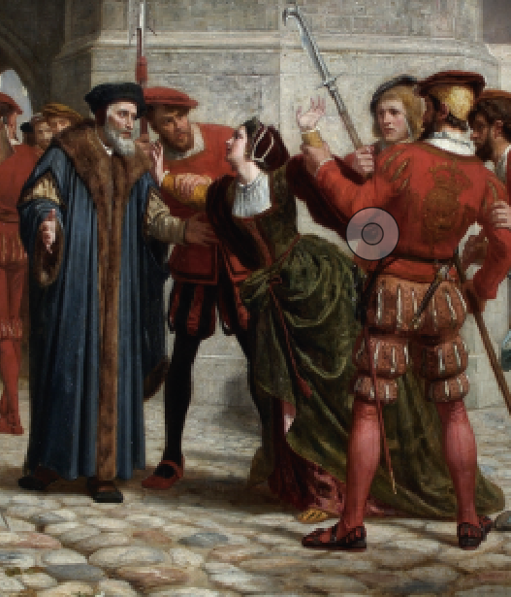

Curators pick traitors!
With the new series of BBC’s ‘Celebrity Traitors’ gracing our screens this autumn, what better time to expose some of our own? Chief Historian Tracy Borman presents a short, dark history of treason, while our faithful curators and researchers each nominate their favourite palace-connected villain

In the year 1348, a devastating epidemic swept across England. The bubonic plague – better known as the Black Death – wiped out as much as half of the population and sparked years of economic hardship. The same year, another – apparently far less significant – event took place. A Hertfordshire man named Sir John Gerberge was convicted of treason for falsely imprisoning William de Boletisford and taking his horse, refusing to release him until he coughed up £90. A contingent of powerful barons protested to King Edward III that Sir John was no traitor and that a new law was required to more accurately define what treason was. The result was the Treasons Act of 1352. This stipulated that to kill, or attempt to kill the monarch, to violate the monarch’s immediate family, or to wage war against the Crown or state was treason. The definition has held true for almost 700 years, and the Act remains in force today.

Edward III’s Act changed the relationship between Crown and people forever. Over the centuries, monarchs used it to punish their enemies, strike fear into their subjects and wield sovereign power. The traditional punishment for treason was to be hanged, drawn and quartered, which proved an effective deterrent for most would-be traitors. But the execution site outside the Tower of London still enjoyed a roaring trade, particularly during the Tudor period when close favourites, ministers and even wives found themselves on the wrong side of the law (and axe). Two of Henry VIII’s wives (Anne Boleyn and Catherine Howard) were convicted of treason and beheaded at the Tower.

Throughout history, traitors have been big box office. Tens of thousands of people descended on Tower Hill to watch the latest execution. Football-style stands were built, souvenirs and snacks sold, and people even clung to the rigging of ships on the Thames to get a view as the likes of Thomas Cromwell, the Duke of Monmouth and Lord Lovat met their grisly ends. Then in 1649, the Treasons Act that had been used by the Crown as a means of control for 300 years was suddenly turned against it when King Charles I was declared a traitor to the state and executed outside the Banqueting House on Whitehall. The last execution for treason at our palaces was that of Second World War spy Josef Jakobs, by firing squad at the Tower in 1941.

But how many of these traitors were, in reality, 100% faithful? Anne Boleyn’s only real crime was not giving Henry VIII a son, whereas poor Walter Raleigh (executed for treason in 1618) had done nothing worse than fail to find the fabled City of Gold, which didn’t exist anyway! It seems treason, like beauty, has always been in the eye of
the beholder.

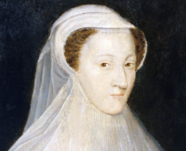
I nominate … Mary, Queen of Scots
l ‘Well, what do you think of your Queen of Scotland?’, Elizabeth I ranted to a hapless ambassador after hearing of Mary, Queen of Scots’ treasonous activities. ‘With black ingratitude and treachery she tries to kill me who so often saved her life.’ For the best part of three decades, the Scottish queen had been a thorn in Elizabeth’s side. As a staunch Catholic with a strong blood claim to the English throne, she had been at the heart of numerous plots to oust Elizabeth and take her crown. Even after she became the Queen of England’s prisoner in 1568, the danger persisted. Then in 1586, Elizabeth’s spymaster Sir Francis Walsingham uncovered Mary’s involvement in the Babington Conspiracy. She and the plotters had been corresponding in secret – or so they believed. But Walsingham had intercepted every letter, including the one that sealed Mary’s doom. Her order to ‘set the six gentlemen [assassins] to work’ made a lie of all the sickly-sweet missives she had sent to her cousin Elizabeth over the years, assuring her of her loyalty and devotion. Mary was executed at Fotheringhay Castle in February 1587 and has gone down in history as a tragic heroine. Don’t believe a word of it: the Queen of Scots was 100% traitor.
Tracy Borman, Chief Historian

DISCOVER MORE
Join Chief Historian Tracy Borman as she explores some of the most notorious executions at the Tower of London in our video ‘Executions at the Tower of London’ on the Historic Royal Palaces YouTube channel.

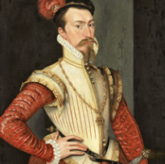

I nominate … Robert Dudley, 1st Earl of Leicester
To many in Tudor England, Robert Dudley was a notorious traitor. Yet he managed to dodge accusations throughout his life. Swept up in his father’s plot to crown Lady Jane Grey, Dudley was thrown in the Tower by Mary I in 1553. Though he left the fortress with his head intact, Dudley continued to attract suspicion as the powerful favourite of Elizabeth I. He was long rumoured to be her lover – an accusation she always denied. But Dudley was her near-constant companion and a much-discussed marriage candidate. One problem? He was already married. When Amy Dudley (née Robsart) was found dead at the bottom of a staircase in 1560, suspicion soon fell on her ambitious husband. Dudley was away at the time, and Amy’s death was ruled an accident. However, his conveniently single status encouraged virulent rumours at home and abroad. Queen Elizabeth never married Dudley, but their attachment continued to create scandal. His secret marriage to Lettice Knollys enraged the Queen, whilst enemy whispers warped Dudley into a conniving villain who exploited his position for power and wealth. Favourites like Dudley played a dangerous game, risking everything to stay close to the Crown. Despite all the rumours, lies and love triangles, Elizabeth trusted her faithful ‘sweet Robin’ until his death in 1588.
Minette Butler, Assistant Curator (Public History)

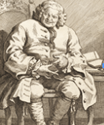
I nominate … Simon Fraser, 11th Lord Lovat
Simon Fraser, 11th Lord Lovat, the last man in Britain to be beheaded, died on Tower Hill in 1747 for his involvement in the failed 1745 Jacobite rebellion, led by Charles Edward Stuart (‘Bonnie Prince Charlie’) to overthrow George II. Following the Jacobite defeat at Culloden, Lovat, aged 80, was captured and brought to the Tower. While Lovat was confined at Fort Augustus, Colonel Joseph Yorke met him and recalled, ‘he has begg’d to make [the journey to London] by land, for he says the sea would certainly kill him […] as nobody wished him any other Death than the axe.’ Never without a quip, when Lovat was finally brought to the Tower, according to the writer, Horace Walpole, the wily old highlander boasted that if it was not for his age, he should have escaped with ease.

Throughout his trial, Lovat remained belligerent. Elizabeth Yorke, whose father conducted the trial as Lord High Steward, observed that Lovat was ‘complaining of blindness & deafness yet reading without spectacles & hearing when convenient.’ Walpole was more critical: Lovat ‘behaved ridiculously, joking and making everybody laugh even at the sentence’. Lovat certainly had his critics, but I secretly admire his roguish spirit in refusing to go quietly!
Jemima Hubberstey, Research Officer

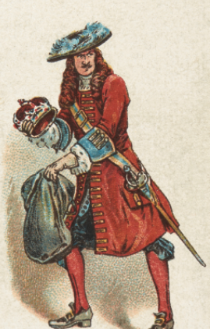

I nominate … Colonel Thomas Blood
Thomas Blood is probably best remembered for trying to steal the Crown Jewels in 1671, yet – astonishingly – escaping punishment. Not only did Charles II pardon him but also restored his lucrative estates in Ireland! Some say that the King found Blood entertaining, or amusingly audacious. However, stealing the Crown Jewels was only the last of many treasonous acts. Blood was a dissenting Anglo-Irish army officer. When the First Civil War started in 1642, he initially supported the Royalists. He later switched sides to follow Cromwell. As a reward, he received land in Ireland and was made a justice of the peace in 1653. Following the Restoration, his estates were confiscated. After this setback, Blood embarked on a not terribly successful criminal spree, aided by fellow disgruntled Cromwellians. Under Blood’s leadership, they plotted to storm Dublin Castle and kidnap and murder the Lord Lieutenant of Ireland. When all these failed, they joined an uprising against the Crown in Scotland (another fail!). Blood fled to the Netherlands (then at war with England) in 1666, proving himself influential and dangerous – a good reason, perhaps, for the King deciding to buy his loyalty. Finally – a win for Blood!
Caroline Wilhelmsson, Assistant Curator (Historic Buildings)

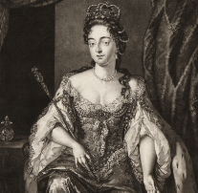
I nominate … Queen Mary II
Is there anything more traitorous than deposing your own father?
In 1688, Mary II agreed to overthrow her father, James II, in the ‘Glorious Revolution’. Her justification? Mary was a staunch Protestant, married to a Prince of Orange, whereas her father had converted to Catholicism before succeeding to the English throne in 1685. In 1688, the consort queen and Mary’s stepmother, Maria Beatrice of Modena, gave birth to a baby boy – a potential Catholic heir. Protestant panic ensued, and seven bishops wrote (in code) to Mary and her husband William asking them to take the throne from James. Even before the birth of Charles Francis Edward Stuart, nicknamed ‘the old pretender’ by some, Mary and her father had exchanged polite letters in which they discussed their religious differences.
Mary now saw it as her duty to save England from Catholicism. After William’s fleet arrived at Torbay in Devon on 5 November, 1688, King James, and his family fled into exile in France, leaving William and Mary the English throne. Heartbroken by what he regarded as his daughter’s treachery, and that of her sister Princess (later queen) Anne, James did not even attend Mary’s funeral in 1694. However, her actions grieved Mary for the rest of her short life. She wrote frequently that unfortunate events or bad feelings were her punishments and tests from God for her part in the Revolution.
Holly Marsden, Assistant Research Curator
DISCOVER MORE
Explore more about Mary II’s life and reign. Visit hrp.org.uk and search ‘Mary II’ or browse ‘History and Stories’.

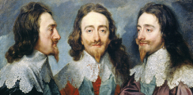
I nominate … King Charles I
How can a king be a traitor? How can a man who many believed was second only to God and whose law the country lived by, be put on trial? These were the questions facing the Parliamentarians who sat in judgement over Charles in January 1649. Despite the dubious legality of the proceedings the outcome was inevitable. Guilty. On 30 January, having bid a tearful farewell to his children, he was executed outside Banqueting House. Charles’ relationship with Parliament was as frosty as that cold January from the start. His arrogance, his fondness for expensive art and even more expensive foreign wars, and his marriage to a Catholic all eventually led to civil war. It was a war so awful that some 200,000 people died, and so it was as a war criminal that Charles stood trial, accused of treason against his own people, responsible for the deaths of so many. The extent of his guilt continues to divide. For some he is the symbol of autocratic monarchy, for others a martyr. He was judged to be a traitor to his people, but he remained faithful to his beliefs. His legacies are therefore difficult to pin down, but politically these events paved the way for our constitutional monarchy, whilst culturally his art-collecting formed a basis for our nation’s collections.
Alden Gregory, Curator (Historic Buildings)

SEE FOR FREE
Experience four centuries of art, architecture and history on an Open Day at Banqueting House. 01 November and 20 December; pre-booking required.

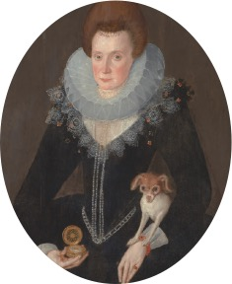

I nominate … Arbella Stuart
Surely not! Arbella is better known as one of the more poignant figures associated with our palaces. A great-granddaughter of Henry VII, she possessed one of the strongest hereditary claims to the English throne during her lifetime.

Well educated and with literary interests, Arbella enjoyed a privileged lifestyle, spending time at Hampton Court Palace and other royal residences, However, in 1610 she secretly married William Seymour, a descendant of Henry VII, without the permission of James I. The marriage united two dynastic claims, raising fears that Arbella and William could become the focus of political opposition. Conveniently branded as a traitor, Arbella was placed under house arrest.

In 1611, she attempted escape with her husband. William reached Flanders safely but sadly Arbella was captured and confined in the Tower of London. She died there in 1615, possibly from illness, or starvation.

To me, Arbella was neither rebel nor conspirator in the conventional sense. Rather, she was a casualty of dynastic politics and, it could be argued, of her defiance in the face of mortal danger. Her fate, like that of many before her, encapsulates the ‘curse of royal blood’.
Alice Blows, Curator (Historic Buildings)
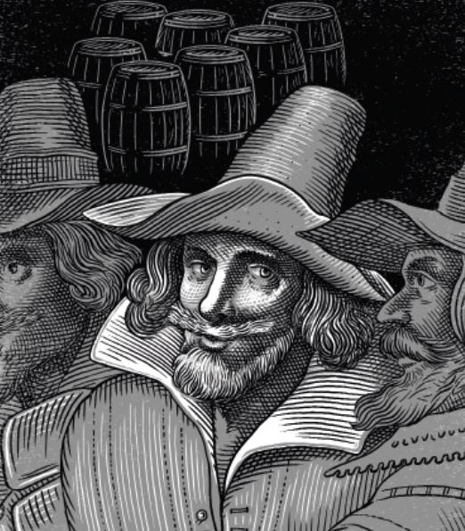

I nominate … guy fawkes
Perhaps the most famous traitor ever (Alan Carr aside) Guy, or Guido, Fawkes even has his own commemoration every 5 November. Notorious for ‘gunpowder, treason and plot’, Fawkes was born in York in 1570 and converted to Catholicism when young. He fought in Catholic Spain, and returned to England in 1604, now part of a passionate group of Catholic conspirators. Angry at James I’s intolerance of their faith, they plotted to assassinate the King and his heir while they attended a session of Parliament. The plotters leased a cellar under the House of Lords and planted barrels of gunpowder; Fawkes had the job of lighting the fuse at the crucial moment.
But the plotters were betrayed and Fawkes was caught red-handed. Arrested and taken to the King, Fawkes defiantly told him his only regret was failing. He was then interrogated in the Tower of London to reveal his co-conspirators, resisting until the King sanctioned ‘harsher tortures’, which likely meant the rack. He was executed for treason in Old Palace Yard, Westminster, in January 1606.

Guy Fawkes was guilty of one of the boldest acts of treason in British history and paid the ultimate price. However, I can’t help but admire his determination, defiance and sheer nerve: he really was the ultimate traitor.
Kate Clements, Curator of Collections
SEE FOR FREE
Want to meet more traitors? Explore our permanent exhibition ‘Imprisonment at the Tower’ in the Beauchamp Tower and uncover the stories of the prisoners who passed through the fortress – in the very rooms where some of them were confined.

CHRISTMAS EVENTS
WINTER PALACE
As the nights draw in and winter settles over Hampton Court Palace, we are weaving a very special Christmas spell to awaken our mythical beasts for the party season. This year, they will take centre stage in our festive celebration. Join us and let the magic begin!
Yes – you shall go to the ball! This year, we’ve dreamt up a brand-new festive tradition, Winter Palace: The Christmas Beast Ball, inspired by the marvellous, mythical creatures that live all over the palace. Some lurk in hidden corners, others in full glorious view across the Moat Bridge. Gaze up underneath a gateway, or scan a ceiling, look closely at a carved detail and you’ll discover lions, unicorns and other bizarre heraldic creatures (a swivelling-horned yale, anyone?)
each with its own story and symbolism.

Over the festive period, discover the spirit of Christmas in historic rooms dressed in wintry blues and shimmering silvers, where costumed performances and merry music whisk you away to the ball of the palace beasts.
Along the way, you’ll encounter friendly mythical creatures, moments of mischief and perhaps even tiptoe past a sleeping dragon, dreaming his way through
the festivities. Meanwhile, Seymour Panther, the palace’s Lord of Revels, ensures the festivities never lose their sparkle.
SEE FOR FREE
You are invited to a celebration like no other; welcome to Winter Palace. 28 November 2026 – 03 January 2027; pre-booking required.

MEET THE BEASTS

Extraordinary creatures are gathering for The Christmas Beast Ball. From ancient guardians to playful mischief-makers, each has a role to perform in the celebrations.
Unicorn Foal – Spirit of Belief
The Winter Palace’s most precious and mysterious guest, who only appears to those who still believe …
Dragon Guardian – Ancient Keeper of Time
Sentinel of secrets, guardian of ages, he watches over the ball from within the deepest, most magical slumber.
Winter Phoenix – Miracle of Midwinter
Eternally rising from the frost and snow, she emerges through the ball in a burst of colour and light.
Panther – Lord of Revels
Master of mischief, Seymour Panther ensures the Christmas Beast Ball will have plenty of sparkle and fun!

More to explore
Make the most of your membership this Christmas. Extend your day with a glide around our famous ice rink, eat, shop and be merry at our popular Festive Fayre, or join us for an atmospheric evening of traditional carols.

Skate through history
Hampton Court Palace Ice Rink
Experience a regal day out where elegance and history meet the excitement of ice skating at this iconic palace. 20 November – 03 January 2027 (excluding Christmas Day). Separate ticket; pre-booking required. Members save 10% or more on skating tickets.
Use HRPMEM15OP (off-peak); HRPMEM10P (peak); HRPMEMFAMILY15 (Family off-peak).

Eat, shop and be merry!
Hampton Court Palace Festive Fayre
Experience a ‘truly magical day’ at this year’s Festive Fayre. For two weekends in December, more than a hundred independent producers will fill the Great Fountain Garden with unique gifts and tasty festive treats, accompanied by live music and plenty of Christmas cheer. 04 – 06 and 11 – 13 December 2026; members go free, pre-booking required.
DISCOVER MORE
Tempted to try something different for Christmas dinner this year? Discover the surprising history of the boar’s head feast in our video ‘A Medieval Christmas Tradition – A Victorian Recipe!’ on the Historic Royal Palaces YouTube channel.

Enter our competition for your chance to win five tickets for you and your guests to enjoy a magical skating session together. To enter, visit hrp.org.uk/membership/ice-rink/competition and complete the entry form by 31 October. Terms and conditions apply.

MEMBER EVENTS
Members’ Christmas Dinner and Shopping Evening at Hillsborough Castle and Gardens on 03 December
Join us for a three-course festive menu, then browse our beautifully decorated shop, filled with seasonal delights. Enjoy a special 20% members’ discount at the shop. Price: £40. Pre-booking required.

Members’ Carols by the Christmas Tree at Hillsborough Castle and Gardens on 10 December
Join us for Christmas carols, a warm drink and a festive treat under the stars. Price: £5 adults, children go free. Pre-booking required.
Members’ Carol Services
Sing in the season at our Members-Only Carol Services. Tickets for
09 and 14 December at Hampton Court Palace and 15 December at the Tower of London go on sale 04 November at noon. Price: £30 adults, £17 children (under 5s do not need a ticket). Pre-booking required.

SHOPPING GUIDE
ALL WRAPPED UP!
Feeling a bit ‘present tense?’ Relax and let us inspire you with this gorgeous selection of Christmas gifts, all available at your members’ discount. Discover many more ideas for all the family online at historicroyalpalaces.com

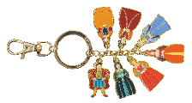
Henry VIII and queens charm keyring
£7.00; member price £6.30
Unlock a Tudor lover’s heart with this fun, enamel-painted charm keyring, featuring Henry and all six queens (each named on the reverse). The carabiner clip makes it easy to securely attach your keys.
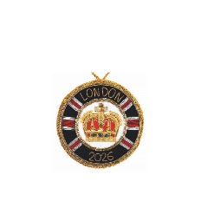
2026 London decoration
£20.00; member price £18
Bring back happy memories of a visit made this year with this handmade hanging commemorative decoration, exquisitely embroidered with a gold crown. Perfect for your Christmas tree. 100% velvet, polyester inner filling. Diameter 9cm.

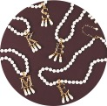
Anne Boleyn personalised necklace
£65.00; member price £58.50
This striking, gold-plated pendant with teardrop faux pearls is inspired by a portrait of Anne Boleyn. Choose your initial! Available online only. Gold plated, 43cm necklace with 8cm extension chain.

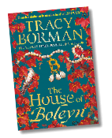
The House of Boleyn by Tracy Borman
£22.00; member price £19.80
Combining drama, danger and passion in this new historical fiction, our Chief Historian brings the Boleyn family’s rise and fall to vivid life. Every history fan will adore this powerful and emotional novel,
signed by the author. Hardback. Published by Hodder & Stoughton.

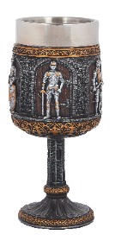

KNIGHTS AND ARMOUR GOBLET
£28.00; member price £25.20
Perfect for medieval style merrymaking this Christmas! Intricately detailed armour, highlighted in gold for effect, with a stainless steel removable inner cup for washing up.
Height 17.5 cm.

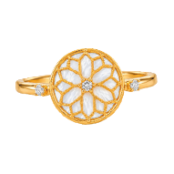
Chapel mother-of-pearl ring
£100; member price £90
This lovely mother-of-pearl and white cubic zirconia ring is inspired by the Wolsey Room ceiling and Astronomical Clock at Hampton Court Palace. 18k brushed matte gold-plated sterling silver. Available in sizes L, N and P.

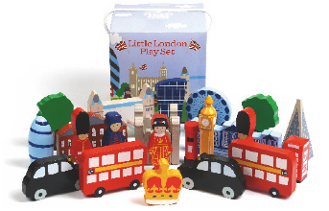
Children’s little LONDON play set
£20.00; member price £18
This lovely play set has 22 chunky pieces, including famous London landmarks such as Tower Bridge, Big Ben, the Shard … and of course, the Tower of London and Beefeaters. Exclusive to Historic Royal
Palaces. MDF and lotus wood, 22 pieces, suitable from 3 years.

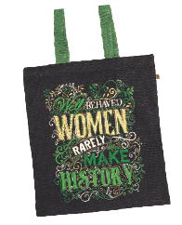

‘Well Behaved Women’ book bag
£18.00; member price £16.20
Do you know someone who isn’t afraid to make a stand for what they believe in? This tote, emblazoned with ‘Well behaved women rarely make history’ in green and gold, will show them you appreciate their trail-blazing style! 100% printed cotton, 40 x 36cm.
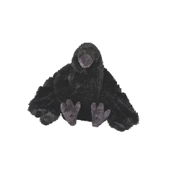
Branwen the raven soft toy
£18.00; member price £16.20
The Tower of London’s feathered ravens might look fierce (and in legend, they protect the realm) but our Branwen’s a real softy. She’d rather have a cuddle than nip your finger, any day. Soft plush, 25cm tall.

Gift membership this Christmas
Give your loved one a gift they’ll treasure this Christmas. From £75, a Historic Royal Palaces membership unlocks a year of unforgettable adventures at the UK’s most iconic royal palaces and gardens. From spine-tingling ghost stories at the Tower of London to wandering the maze at Hampton Court Palace, it’s the perfect present for history lovers, explorers and curious minds. They’ll enjoy unlimited entry, exclusive discounts, and access to behind-the-scenes events. Buy now at: hrp.org.uk/gift-membership

SAVE MORE
Members save 10% year round in our shops and online using code MEMBER26.*
*Exclusions apply

HISTORY & STORIES
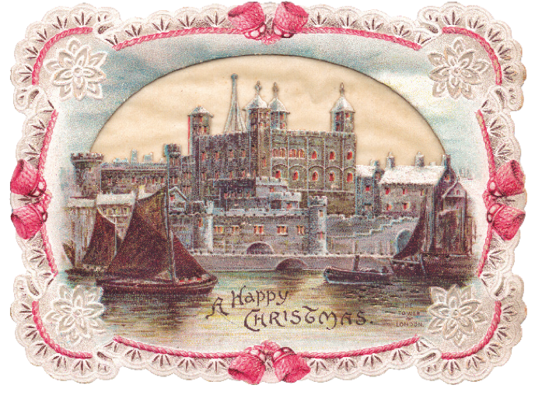

THE FESTIVE FORTRESS
Queen Victoria’s reign transformed the celebration of Christmas, even behind the formidable walls of the Tower of London. Assistant Curator Minette Butler reveals that life was surprisingly festive and fun inside the 19th-century fortress

Tower residents (including the Yeoman Warders) embraced the period’s renewed enthusiasm for the winter season, filling the fortress with dancing, dinners and Christmas trees. Meanwhile, the introduction of bank holidays lured thousands of tourists to enjoy the Tower’s many historic sights each Boxing Day. Together, these stories paint a vibrant, festive portrait of life inside the fortress during the 19th century.

A day out at the Tower
Christmas was one of the Victorian Tower’s busiest times of the year. Long established as a public showplace, the fortress appealed to the era’s romantic fascination with all things medieval and was a must-see for anyone visiting London for the holidays.

Tourists enjoyed many of the same sights seen inside the fortress today, from well-established attractions like the Crown Jewels and the Tower Armouries to the graffiti in the Beachamp Tower (opened in 1851) and the scaffold site (first commemorated in 1866). Yeoman Warders escorted visitors around these curiosities, enlivening them with dramatic tales of famous prisoners and ghastly punishments.

However, some tourists sought other attractions. On 20 December 1841, John Dickens (father of the famous author of A Christmas Carol) visited to inspect the ruins of the Grand Storehouse, once home to the Tower Armouries. The building had burned down the previous October, leaving a twisted pile of melted weapons and charred rubble – what Dickens described as ‘eccentric unions’ and ‘monstrosities of extraordinary character’.

Festive tourism took off in 1871 with the Bank Holidays Act, which made St Stephen’s Day, better known as Boxing Day, a day of leisure. This meant more people could visit the Tower than ever, particularly working-class families or those travelling from the countryside. Boxing Day visitors soared from around 1,500 in 1871 to as high as 8,000 by the end of the century.

Sadly, most tourists missed out on any Christmas card-like views of the fortress. Eyewitnesses complained about the ‘muggy, sloppy, drizzly and nasty’ weather that plagued visitors each Boxing Day. Still, they made the best of it – commentators observed that the fortress was ‘always a favourite resort for people on a holiday’.

But the Tower’s grim reputation didn’t always invoke Christmas cheer. In December 1871, the Illustrated London News amused its readers with the tale of a little girl invited to inspect a set of thumbscrews by a Yeoman Warder. Full of festive spirit,
he reminded her ‘how thankful she ought to be that she was not born in the dark ages, when she might have been racked, and (who knows?) perhaps burnt at the stake for truth’s sake’ – and a happy new year!

A Constable for Christmas
Even the busy Christmas season did not interrupt the Tower’s ceremonial duties. On 23 December 1871, just three days before the first Boxing Day Bank Holiday, the fortress gathered to install Field Marshall Sir George Pollock as the new Constable of the Tower.

Again, the fortress had no white Christmas. Instead, Tower Green was engulfed in thick black fog that turned the lunchtime ceremony ‘dark as midnight’, shrouding the scarlet clad Yeoman Warders in dreary gloom.

Spectators gathered in the shadow of the White Tower as Pollock received the keys to the fortress by lantern light, followed by cheering cries of ‘God Save the Queen’. Among the crowd was one unusual attendee – a ‘fantastically caparisoned goat’, who was the garrison’s beloved mascot.

Trees and treats
Beyond the tourists and traditions, the Tower community had their own Christmases to celebrate.

Families living inside the fortress, including the spouses and children of the Yeoman Warders, married soldiers and other employees, would have enjoyed many of the now iconic traditions popularised in the 19th century, including Christmas cards and Christmas crackers.

At the centre of these celebrations were Christmas trees. Brought to England by Queen Charlotte and popularised by Queen Victoria and Prince Albert, many Tower families would have had their own fir trees decorated with candles, paper chains and small gifts.

But the best Christmas trees belonged to all the Tower’s children. First reported in the 1880s, these trees were gifts from the garrison’s commanding officers. They invited the children to choose a toy from under the branches – maybe a doll or their own penny trumpet. Accompanied by tea, cake and plenty of games, this much anticipated festive treat was a welcome break from the routines of Tower life.

Dancing, dinners and revelling ravens
The Tower enjoyed many merry moments over the last weeks of December. In 1851, the Scots Fusilier Guards, then stationed at the fortress, organised a glittering Christmas ball in the barracks. Complete with music, supper and distinguished guests, most notably the 82-year-old Duke of Wellington (then Constable of the Tower), dancing lasted ‘with untiring energy’ well into the early hours of the morning.

Among the most anticipated festivities was Christmas dinner. In the barracks, soldiers decorated the mess rooms with evergreens and paper chains before sitting down to beef, turkey and plum pudding – all popular treats on the Victorian Christmas table. Similar scenes played out in homes all around the fortress, where families enjoyed food, games and giving gifts.

Even the ravens took part in the celebrations. In 1896, one newspaper reported that the famous birds were ‘well attended to’ and some were even conveyed to the mess rooms (maybe to enjoy a share of the officers’ Christmas beef).

The Tower of London has seen nearly a thousand Christmases
come and go. Though tales from the fortress may not always sound like A Christmas Carol, they give us a fascinating glimpse into the Tower during Queen Victoria’s reign.
SEE FOR FREE
Experience the spirit of a Victorian Christmas at the
Tower of London this festive season (see page 06).
27 November – 03 January; no pre-booking required.

HISTORY & STORIES
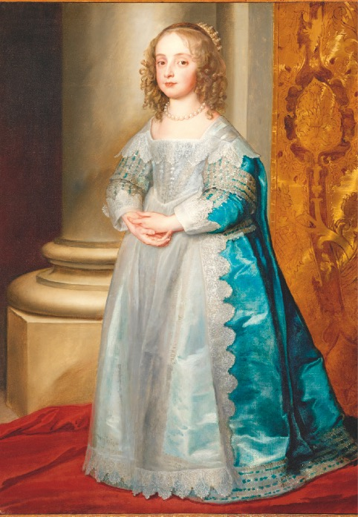

ON THIS DAY

4 November 1631
Princess Mary Stuart is born
Princess Mary was the eldest daughter of King Charles I and Queen Henrietta Maria, and sister to the future kings Charles II and James II. At the age of 9, she was married to the 14-year-old William II of Orange in a ceremony that took place at the Chapel Royal in Whitehall Palace. Shortly before leaving for the Netherlands, Mary was given the title ‘Princess Royal’ by her father, establishing a lasting British tradition that the eldest daughter of the sovereign may use this title.

Following the death of his father in 1647, William succeeded as Stadtholder and Mary became the Princess of Orange, but she was widowed a few years later at the age of 19. Eight days after her husband’s death in 1650, Mary gave birth to a son, William III of Orange, who would later rule England alongside her niece, Queen Mary II. When her brother Charles II regained the British throne during the Restoration of the Monarchy in 1660, Mary travelled to London to celebrate his return and to secure the future of her young son, whom she had left behind in the Netherlands. However, her homecoming was tragically short-lived. Mary contracted smallpox and died at Whitehall Palace on 24 December 1660 at the age of 29. She was buried in Westminster Abbey next to her brother Henry, Duke of Gloucester, who had also succumbed to the disease just a few months earlier.

14 October 1940
Kensington Palace is hit in the Blitz
In 1940, the Blitz raged over the skies of London as the Luftwaffe attempted to carry out Hitler’s threat to destroy the capital. Numerous incendiary bombs fell on the roofs of Kensington Palace, but most were quickly extinguished by the palace foreman and the local fire squad. However, on the night of 14 October the fires could not be brought under control and burned for several hours. Fortunately, no lives were lost but the damage was extensive. Several of the private apartments were badly affected, including the residence of Princess Alice of Athlone (the last surviving grandchild of Queen Victoria) and her husband, the Earl. Their daughter recalled the devastation: ‘Kensington Palace was quite uninhabitable … Our apartments there were in complete chaos. The disastrous fire had destroyed part of our roof and attic rooms … No window frames were left, and all our furniture, books and pictures were heaped higgledy-piggledy in the drawing room and dining rooms … Aunt May [Queen Mary] even came to help wash china …’. In the State Apartments, the roofs of the Queen’s Drawing Room and two small rooms behind were also totally gutted.

Over the following five years there was another seven hits on or near the palace that caused further damage but in the midst of the war, little could be done apart from making the building stable. However, these temporary fixes would be all that protected the palace for decades to come, as King George V ordered that no money be spent on repairing Kensington while many Londoners remained homeless. It was not until June 1949 that the State Apartments were opened to the public again, and only in the 1980s was the last of the damage finally made good.
SEE FOR FREE
You can find this elegant portrait in the Cumberland Art Gallery at Hampton Court Palace.

23 November 1499
The execution of Perkin Warbeck
Perkin Warbeck was a young man who claimed to be Richard, Duke of York, the younger of the Princes in the Tower. Warbeck alleged that his brother Edward had been murdered in the Tower, but that he had been spared because of his age and innocence and had spent the intervening years on the run. He claimed that he was the rightful Yorkist heir to the English throne.

Warbeck spent nearly a decade attempting to overthrow King Henry VII. His story was sufficiently plausible to be accepted by those who wanted to believe it, and he gained strong support in Ireland and Europe, convincing several important people, including Maximilian I, Holy Roman Emperor and James IV of Scotland, that he was ‘Richard IV of England.’ He also won the backing of some of Henry VII’s most senior courtiers and of Margaret of York, the aunt of the real prince who formally recognised him as her nephew.

Warbeck was a major threat to the new Tudor dynasty. Were he really the younger Prince in the Tower, his claim to the throne would be far stronger than that of the Lancastrian Henry VII, whose right of succession was weak and largely based on winning the Battle of Bosworth Field. A surviving son of Edward IV would have been the undisputed, legitimate Yorkist heir.

In 1497, Warbeck attempted to invade England. He failed and was forced to publicly admit he was an imposter. He was imprisoned in the Tower and initially treated leniently. However, when word reached the King that he had been conspiring with his fellow prisoners, Warbeck was found guilty of treason and hanged.

15 October 1537
Edward VI is christened at Hampton Court Palace
l At 2am on 12 October 1537, after enduring a gruelling two-day labour, Jane Seymour gave birth to ‘the most beautiful boy that ever was seen,’ the tiny Prince Edward, future King Edward VI. His father, Henry VIII, was ecstatic. Wild celebrations took place across the country, with two thousand rounds of ammunition being fired from the Tower of London to herald the birth.

The Prince was christened in a lavish ceremony in the Chapel Royal at Hampton Court three days later, where a huge octagonal platform was built for the font, allowing guests a good view of the proceedings. The christening was held at night and began with a great procession that wound its way through the palace led by 80 knights, squires and gentlemen guided by a series of torch bearers. Behind them came hundreds more: the staff of the Chapel Royal, the choir, ambassadors, bishops, abbots, courtiers and household officers. Both of Edward’s half-sisters, the 4-year-old Princess Elizabeth (the future Elizabeth I) and the 21-year-old Princess Mary (the future Mary I), who was to be godmother, were in attendance. The Prince himself was clothed in a delicate white gown and carried under a rich canopy.

Royal protocol dictated that the King and Queen should not attend the christening in person, so after the ceremony, Edward was carried to the Queen’s apartments so that his parents could bless him. But poor Jane Seymour did not enjoy her triumph for long. She sickened just days later and died on 24 October, in the same bedchamber where she had given birth.

DISCOVER MORE
Explore the story of Henry VIII’s ‘precious jewel’ and only son. Visit hrp.org.uk and search ‘Edward VI: The Lost Tudor King’.

HISTORY & STORIES
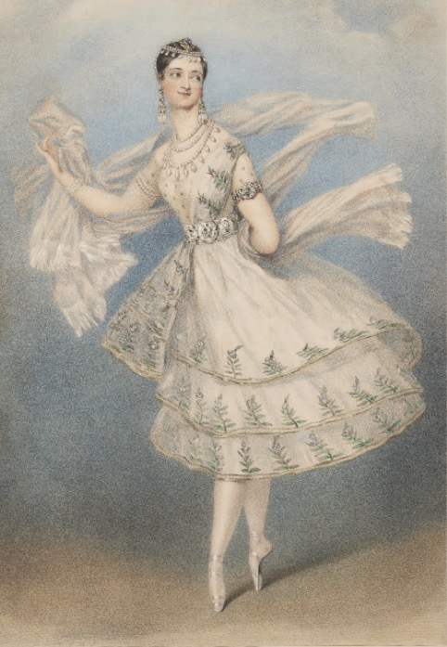

KENSINGTON’S STARSTRUCK PRINCESS
From the moment a young Victoria saw prima-ballerina Marie Taglioni on stage, she was as hooked as any Taylor Swift fan. She made drawings, dolls’ costumes and even dressed up as her teen idol, as Assistant Curator Myles Campbell reveals

On the day she turned 16, Princess Victoria, the future queen, was presented with an array of diamonds, emeralds and turquoises by members of the royal family. Set in precious metals, they signified her high status as heir to the throne. But among the simpler presents she received was something with its own special value in the eyes of the young Princess, a ‘very pretty print’ of the ballerina Marie Taglioni. For teenage Victoria, the print was the Smash Hits poster of its day – a captivating image of her teen idol. Although she was destined to be queen, Victoria was no less susceptible to the power of celebrity than any teenage fan, and during a recent visit to the archives, I was fortunate to unearth an eyewitness account of the moment that made Taglioni the Taylor Swift of her day in the eyes of the Princess.

An enchanted evening
On the evening of 19 April 1831, 11-year-old Victoria made her first appearance at the King’s Theatre, Haymarket, accompanied by her mother, the Duchess of Kent. Known informally as ‘the opera house’, it was London’s premier venue for opera and ballet in the 1830s. The watershed moment was recorded in the journal of her governess, the Duchess of Northumberland: ‘I accompanied their Royal Highness’s [sic] to the Opera – The King & Queen went in state –
& the Duchess of Kent occupied the Duke of Devonshire’s Box, opposite to their Majesties. It was the first time Princess Victoria had been there – Her delight and attention to the music was most natural, & with the Ballet she was not a little pleased – Taglioni’s dancing enchanted her.’

The ballet staged for the royal party in this command performance was Kenilworth by the Neapolitan composer and conductor Michael Costa. According to the critics, Taglioni delighted the house with her ‘matchless accomplishments’, and danced with ‘the utmost grace’. Her Tyrolean folk dance was so admired that it left the audience clamouring for an encore.

Royal role model
The immediate impact on the Princess was a much later bedtime than usual and a passion for Taglioni’s dancing that would grow throughout her teenage years. A surviving contemporary doll from Victoria’s childhood collection can now be linked to this enthralling evening. The doll was made with the help of her attendant and former governess, Louise Lehzen. It portrays Taglioni as she appeared in Kenilworth, wearing a net cap, pink taffeta skirt and carefully embroidered blue bodice. The intricacy and attention to detail of the costume illustrate Victoria’s meticulous observation of Taglioni’s dress, reflecting her impulse to preserve a cherished but ephemeral experience in material form.

This creative response was the first of many that expressed Victoria’s fascination with Taglioni’s movement, appearance and dress. She made more than 40 drawings of Taglioni following the numerous performances she attended, created at least seven more dolls representing her, named a horse in her honour and, in perhaps the ultimate tribute, even dressed up as her. On 6 January 1833, she wrote: ‘After dinner I dressed myself up as “La Naiade”, as Taglioni was dressed, with corals in my hair.’ A contemporary print of Taglioni dressed for this part allows us to imagine how the 13-year-old Princess emulated her role model, with a full skirt, pendant earrings and a crown of corals on her head. A surviving copy of the print in the Royal Collection likely inspired Victoria’s homemade costume, as she is not known to have seen Taglioni perform in the role.

‘She seemed to dance in the air’
Born in Sweden in 1804, Taglioni was the undisputed superstar of 19th century Romantic ballet, a movement associated with other-worldly themes and figures, in which female dancers eclipsed their male counterparts. By pioneering her own highly original form of dancing en pointe – on the tips of her toes – Taglioni appeared to float across the stage, creating a sensation across Europe. The immense grace and control of her movements were central to her appeal for Victoria. ‘She seemed as if she belonged not to the earth’, wrote the Princess, ‘so fairy-like were her movements, and so immense her bounds. She seemed to dance in the air.’

Weighed down by a growing awareness of her responsibilities and pressures as the next monarch, it is easy to see why young Victoria found Taglioni’s escapist form of dance so appealing. Through her ethereal performances and costumes, Taglioni became a significant influence on the Princess’s developing self-image, helping to link dance – whether through dressing up, drawing costumes, making dolls or actually attending the ballet – with ideas of freedom and transcendence. In this way, dance became a much-needed outlet for a young girl coming to terms with the immensity of her future responsibilities.

A tribute to Taglioni
This year, Taglioni has made something of a return to Victoria’s childhood rooms at Kensington Palace, in a new display of objects relating to her career in the 1830s. Included among them is a large-scale print of Taglioni dancing en pointe, amid swirling skirts and diaphanous draperies, just as she appeared in the drawings of the young Princess. If Victoria herself were to return, the intensely romantic image would surely bring back memories of hours spent making those drawings and of a much-loved 16th birthday present.
The print is a reminder that before Victoria wore a heavy crown, she too, like so many teenagers before and since, was once a starstruck young girl who looked up to the role models on her bedroom walls.

BIG ADVENTURES FOR YOUNG EXPLORERS
From hauntingly good adventures to heartwarming festive experiences, we’ve packed the calendar with unforgettable days out for you. Discover, learn, and make memories together with our top picks for all the family. Check hrp.org.uk for details, members go free (unless otherwise stated).

OCTOBER – SPOOK-TACULAR SEASON
24 October – 01 November
Hampton Court Palace
Halloween at Hampton Court Palace
Dare to explore Henry VIII’s notoriously haunted palace this Halloween. Don’t miss atmospheric projections, eerie sound effects and magical spells. Will you spot our famous ghosts haunting the halls?

24 October – 01 November
Hillsborough Castle and Gardens
Halloween at Hillsborough Castle and Gardens
Get closer to nature this Halloween; join a family workshop, navigate the twisty maze and go on a storytelling walk. Some activities require a separate add-on ticket. See website for details.

24 October – 01 November
Tower of London
Halloween at the Tower of London
Immerse yourself in the eerie sights and sounds as you weave your way along cobbled paths and battlements exploring 1,000 years of history.

10 October – 08 November
Hillsborough Castle and Gardens
Scarecrow Parade
See the Walled Garden vividly brought to life with spectacular scarecrows.

Open
Tower of London
Armoury in Action
Get ready for battle! Join our interactive experience and try shooting arrows, brandishing a sword and firing cannon.

NOVEMBER – WINTRY WONDERS
20 November – 03 January
(excluding Christmas Day)
Hampton Court Palace
Hampton Court Palace Ice Rink
Save on family off-peak skating tickets with code HRPMEMFAMILY15.

Weekends until 22 November
Kensington Palace
Power, Perfume and Scandal
Travel back in time to the ultimate party palace, and meet clever Queen Caroline and her conniving courtiers. But despite the festivities, keep an ear out for whispers at court – there’s a scandal brewing …

27 November – 03 January
Tower of London
Victorian Traditions at Christmas
From gift giving to Christmas trees and cards, explore how the familiar Christmas celebrations of today were made popular by the Victorians.

28 November – 03 January
(excluding 24 – 26 December)
Hillsborough Castle and Gardens
Christmas at Hillsborough Castle and Gardens
Step into the magical world of The Gruffalo’s Child on an enchanting daytime trail through the gardens. Discover favourite scenes from the much-loved story, meet the Gruffalo or Santa, and watch The Gruffalo’s Child film. Some activities require a separate add-on ticket.
See website for details.

DECEMBER – FESTIVE FUN IN FULL SWING
28 November – 03 January
Hampton Court Palace
NEW Winter Palace
Start a new Christmas family tradition when you visit The Christmas Beast Ball, the most enchanting event of the season where magical, mythical beasts celebrate in style!

04 – 06 and 11 – 13 December
Hampton Court Palace
Festive Fayre
Browse over a hundred independent artisan stalls to discover special and unique gifts for all ages. Plus merry music from the bandstand, festive treats and delicious street food!

27 – 31 December
Tower of London
The Spirit of Christmas
Experience the spirit of a Victorian Christmas at the Tower of London. Meet the Tower postman as he attempts to deliver a last-minute gift and join in a giant game of pass-the-parcel. Daily live performances.

Open
Tower of London
The Crown Jewels
Tower treasure hunters,
be dazzled by this world-famous collection of 23,578 gemstones.

BOOK NOW
Pre-booking via your Member login is required during select events; look out for the ticket icon. Many events are included in palace admission; some require a separate event ticket. For details, check What’s On at hrp.org.uk.

ON THE SPOT


JOHN BARNES
Chief Executive
As we come to the end of a memorable year celebrating two decades of membership, our Chief Executive, John Barnes, reflects on how members’ support helps us achieve our aims

What do you most want members to feel that they are enabling?
That they’re helping us open up these palaces, to tell richer, more relevant stories and to care for them properly for the long term.
We talk a lot about our ambition to become a charity for everyone but that only becomes real when people like members choose to support us, beyond visiting, over the long term. That support gives us the confidence to plan and think into the future.

What keeps you awake at night?
Right now, we’re facing financial challenges as the global situation impacts our income. Overall, as we speak, visitors to the palaces are down by around 15 per cent, and overseas visitors, especially Americans who represent a third of our audience, are down by a lot more.
The reduction in income is significant, but we’re determined to stay focused on our strategy, to be for everyone, and protect long-term investments, such as education, community work, and major capital projects like the new learning facilities we’re planning for the Tower of London. The reality is that palaces operate on the long wave of time: they need sustained care over generations, while we are constantly managing short-term pressures. The knack is to balance these two things, and that’s where consistent support from members really matters.

What’s something members may not realise that they’ve made possible?
We can welcome large numbers of children to the palaces, free of charge, through supported programmes and travel, because we have a strong membership base. Those experiences can be genuinely transformational. If you bring a child who’s never been to London before to somewhere like the Tower or Hampton Court, their reaction is often just ‘wow’.
It’s that kind of horizon‑expanding moment that membership support makes possible – it allows us to invest ahead, not just operate day to day.

Is there a recent moment that has stopped you in your tracks?
It happens every time I quietly observe groups around the palaces, often multigenerational and multinational, who are all engaging with what we do but in their own ways.
That’s what I find the most compelling about our ambition to be for everyone. We don’t determine how people connect with what we offer, instead we provide the stories and the space, and people find their own way in.
What matters is the connections people make, and the experiences we provide.

What would you say to members who haven’t visited for a while?
A big thank you for remaining a member and, if you haven’t visited for a while, do come back.
It’s easy to think of the palaces as familiar and unchanging but, actually, they’re constantly evolving. There are new exhibitions and programming, freshly conserved buildings, newly presented gardens, and research that provides new insights into our shared history. There’s always something new to see, and new ways of experiencing them.

