Crime & Punishment
In Tudor England
The Beauchamp Tower
TOWER OF LONDON
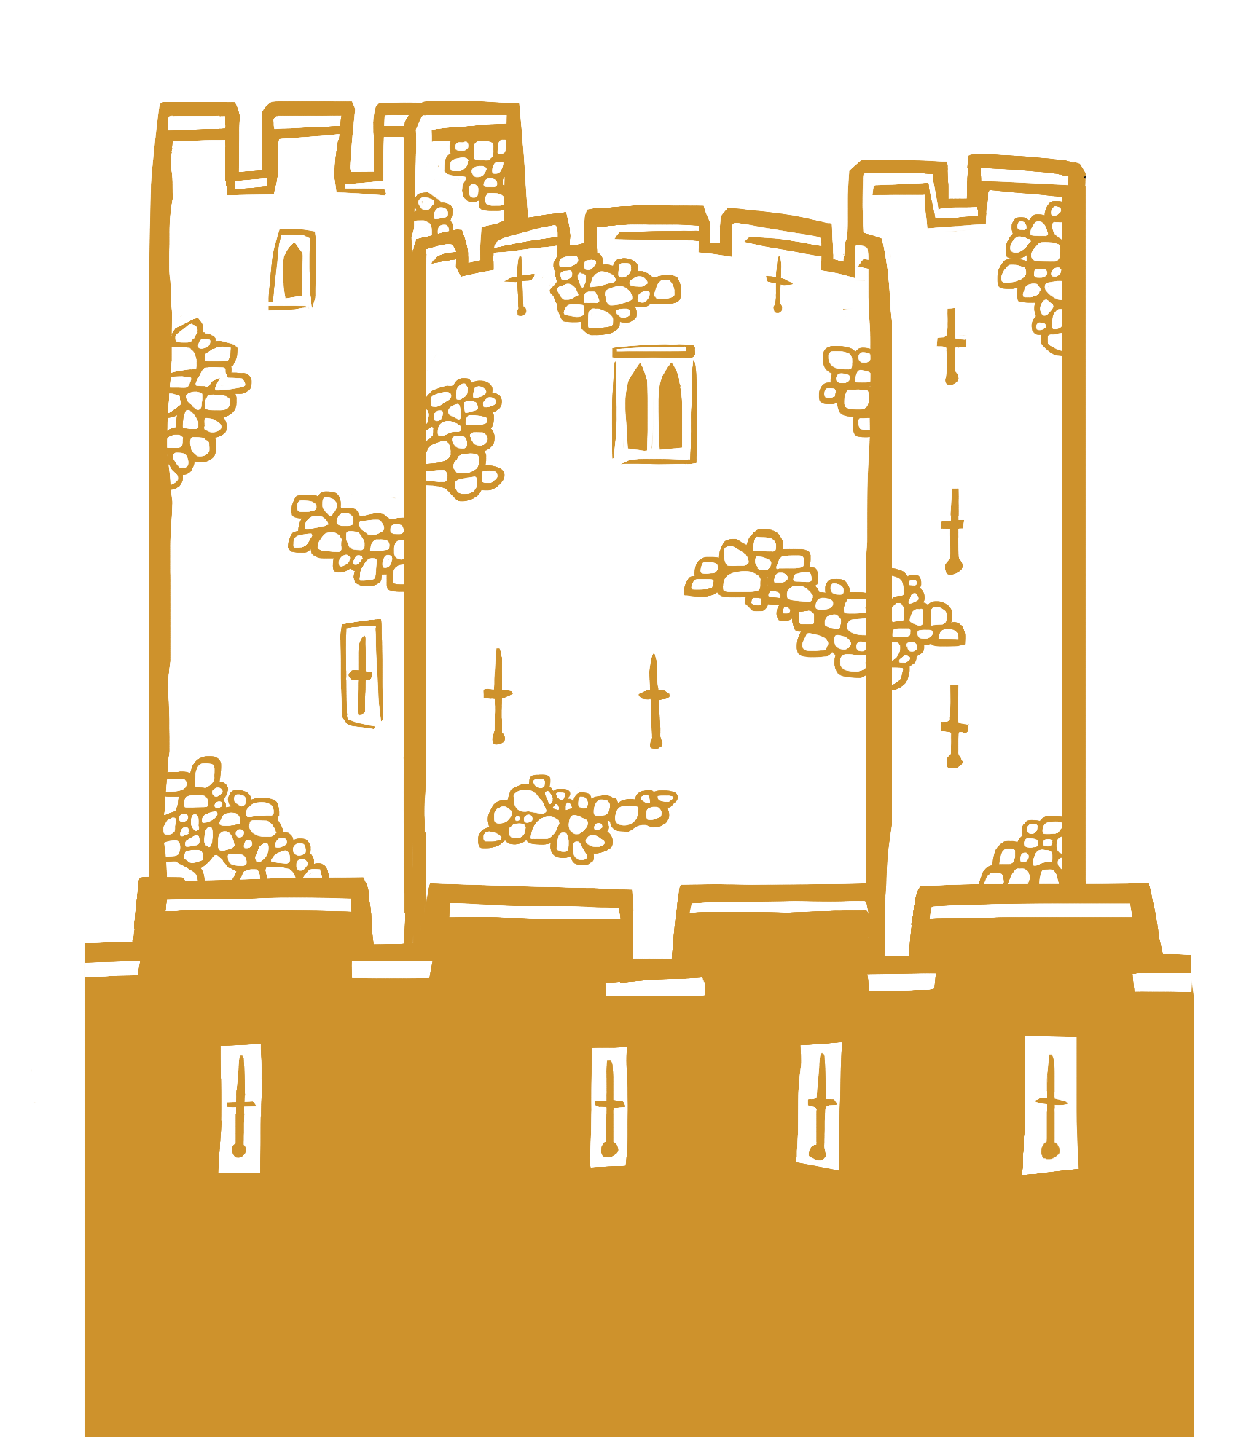
Name: __________________________________________
1 Outside | Building Features
1. Have a look at this map from 1597. Circle the Beauchamp Tower. HINT: The Beauchamp Tower is part of the west inner wall.
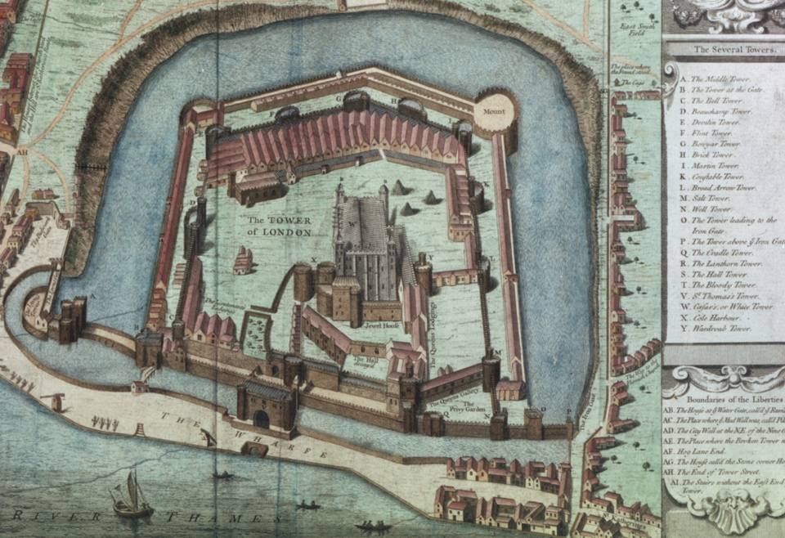
2. What different uses has the Beauchamp Tower had over time?

3. There are not many arrow loops on the east side of the building, but there are lots on the west side. Why might this be?
2 | Ground Floor | Tudor Crime
1. Who was in control in Tudor England? _______________
2. Name 3 different crimes in Tudor England.
3. How do you think people were punished in Tudor England?
Ground Floor | Tudor Punishment
1. Name 3 different punishments in Tudor England.
2. What might be different about prisons for poor people compared to prisons for rich people?

3. Imagine you are a Tudor prisoner here. Use the next page to write a diary entry to describe what it might have been like to be held here.
3 |  | Prison Diary

4 | First Floor | Prisoners’ Graffiti
Have a look at the different graffiti. Think about:
- If you were a prisoner here, what would you choose to carve?
- Would you include your name, a date or any symbols?
Draw your own graffiti carving on this brick.

5 | First Floor | Protestant Prisoners
1. Why did Mary I imprison Lady Jane Grey and Lord Dudley?
Take a closer look at the ‘Jane’ and ‘Dudley’ carvings. Think about:
- How might they have been created?
- Who might have carved them?
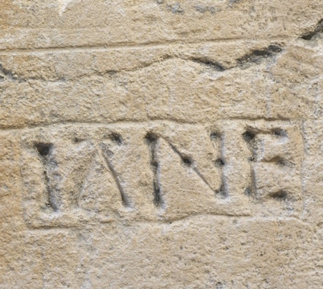  2. What is similar about them? |  | 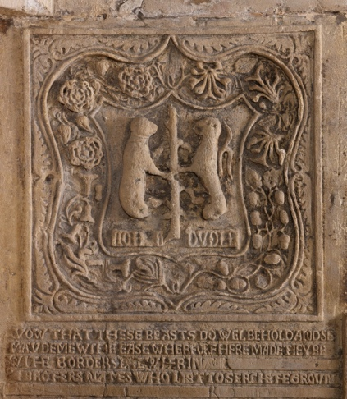
3. What is different about them?

6 | First Floor | Catholic Prisoner
Look closely at the Arundel carving.
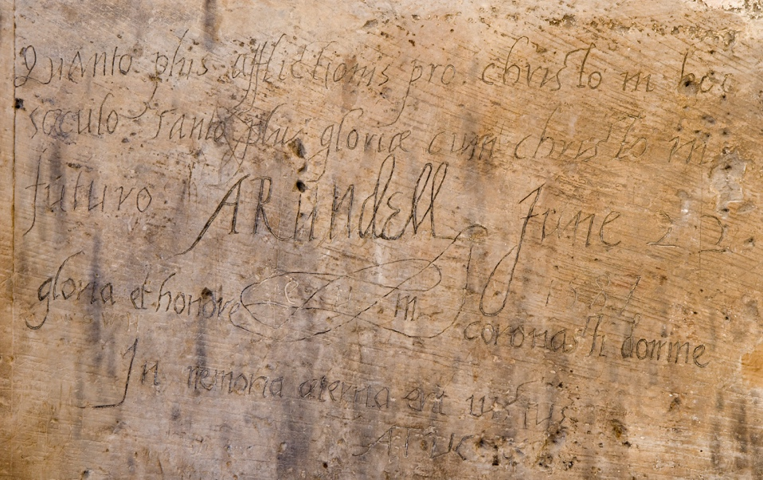
1. Why did Elizabeth I imprison Philip Howard, Earl of Arundel?
2. How do we know this message was left by him?

3. When did he carve it?
4. What language is it in?
5. What words do you recognise that reveal it is about religion?
Instructions
Use this student booklet alongside the interactive Crime and Punishment virtual tour on the Historic Royal Palaces website.

To print as an A4 booklet

- Go to File > Print.
- Select your printer and set it to:
Print on Both Sides (flip on short edge).
- In printer options or printer set up choose:
landscape and A4.
- Check for any scaling options and set them to: 100% or Actual Size. This may also need to be done in File > Options > Advanced > Print > Deselect: “Scale content for A4”
Answers (teacher can delete)
Building Features
2. Defence, prison, visitor attraction, home 3. There are more arrow loops on the west side of the building as this side faced London, where people might have attacked from. The east side of the building faced inside the Tower of London, which would have been safe.

Tudor Crime
1. The Monarch (King/Queen) 2. Stealing, hurting, blasphemy, sumptuary laws, treason. 3. People were punished by whipping, fines, stocks, prison and execution.

Tudor Punishment
1. Whipping, fines, stocks, prison, execution. 2. Prisons for poor people were cold, dirty, cramped and crowded. Prisons for rich people were bigger, had fireplaces, windows and toilets (like the Beauchamp Tower).

Protestant Prisoners
1. Mary imprisoned Lady Jane and Lord Guildford because Mary thought she was the rightful queen. 2. The two carvings were made to remember people who were imprisoned and sentenced to death at the Tower of London, they both feature names of people. They were probably made around a similar time. 3. The Dudley carving is very elaborate and might have been carved by an expert using special tools. It has symbols and a coat of arms and is near the fireplace. The Jane carving is very simple and plain and was likely carved by a prisoner. It is near the window.

Catholic Prisoners
1. Elizabeth imprisoned Arundel because he was Catholic. 2. The name Arundell is in the middle of the carving. 3. 22 June 1597 3. Latin 4. Christo/Christ, Gloriea/Glory, Honore/Honour.


