Religion, Power and Conflict
in Tudor England
The Beauchamp Tower
TOWER OF LONDON
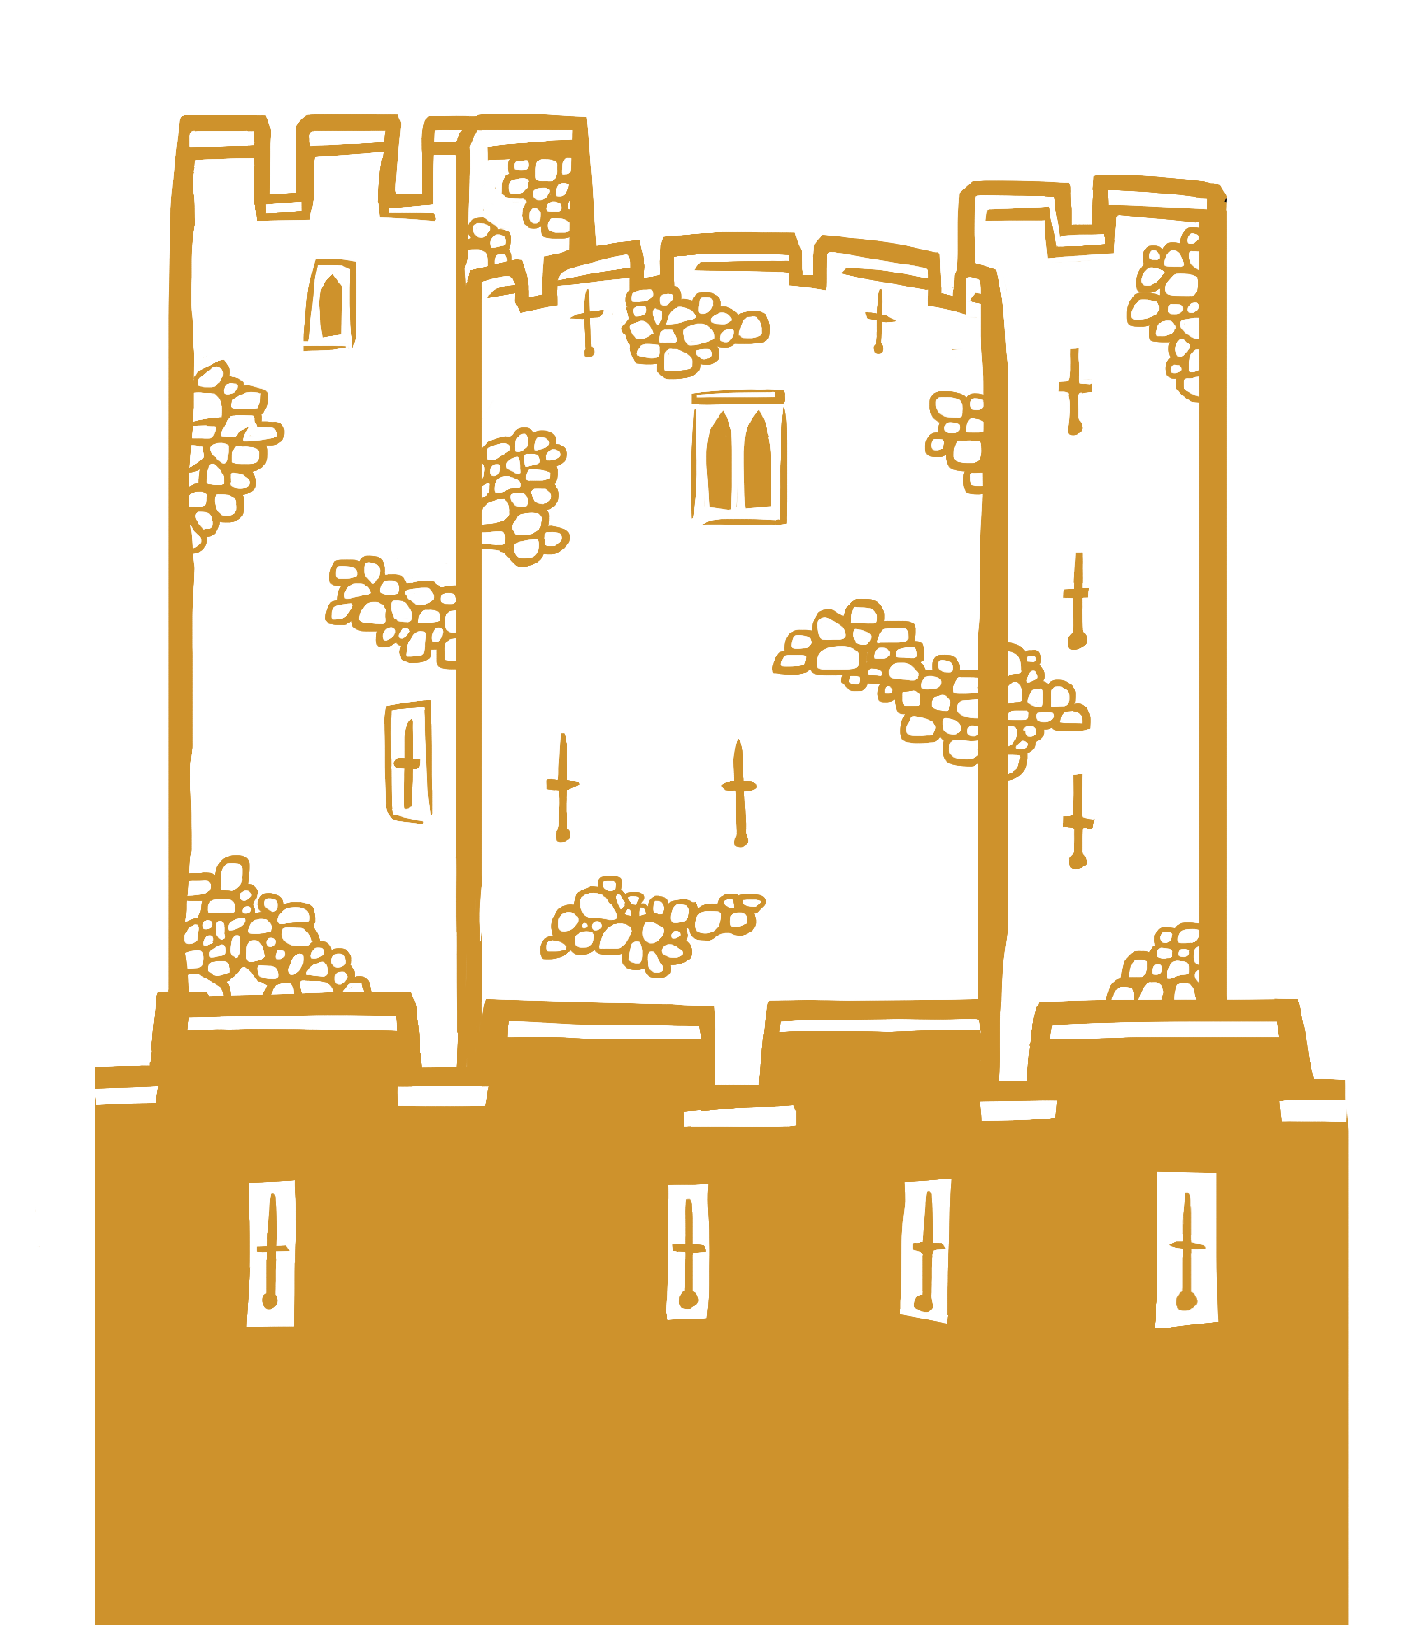
NAME: __________________________________________
1 |  | Outside | Building Features
1. Have a look at this map from 1597. Circle the Beauchamp Tower. HINT: The Beauchamp Tower is part of the west inner wall.
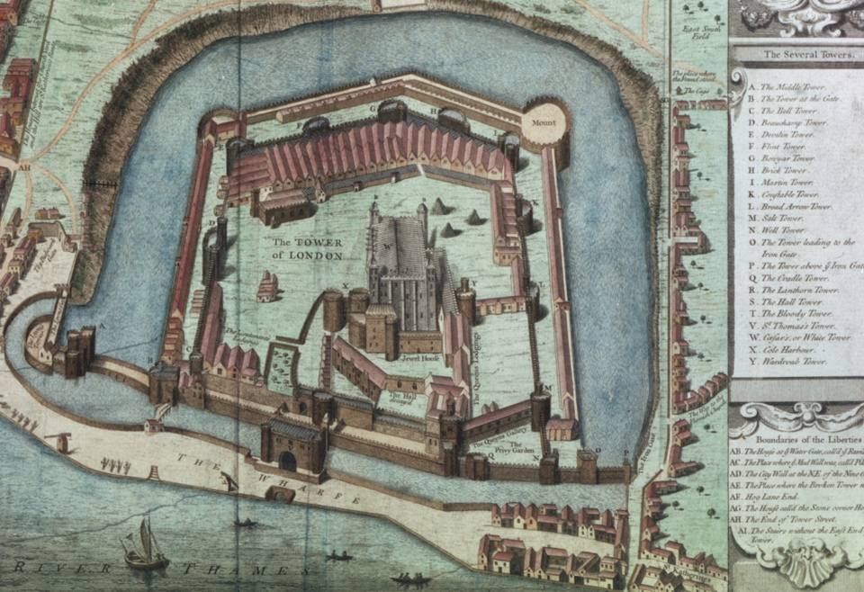
2. What different uses has the Beauchamp Tower had over time?

3. How might the design and location of the Beauchamp Tower have made it useful to Tudor monarchs as a prison?

2 | Ground Floor | Crime & Punishment
1. Who held power in Tudor England?
2. Name two different crimes in Tudor England.

3. Name two different punishments in Tudor England.
4. What evidence is there that this tower was not originally built as a prison?

5. Imagine you are a Tudor prisoner here. Use what you have seen so far to write a diary entry describing what it might have been like to be held here.

3 |  | Prison Diary

4 | Staircase | Religious Rollercoaster
1. What religion were each of these Tudor monarchs?

Henry VIII ____________________ reigned 1509-1547

Edward VI ____________________ reigned 1547-1553

Mary I ____________________ reigned 1553-1558

Elizabeth I ____________________ reigned 1558-1603

2. Create a timeline of the Tudor monarchs’ reigns. As an extra challenge, make your timeline rollercoaster shaped to show the different monarchs’ religions.

5 | First Floor | Prisoners’ Graffiti
1. Look closely at the graffiti. Are there any common themes, images or words?
2. Some of the carvings feature crosses. What does this tell you?
3. List some of the different names you find in the carvings.
4. Choose one prisoner to research and find out more about. Use the following page to record your findings.

- Where were they from?
- When were they imprisoned?
- How did they come to be a prisoner at the Tower of London?
- What happened to them in the end?

Remember: The Tudor monarchs used the Tower of London to silence many people. By researching their stories, you are helping to give them back their voices.
6 |  | Prisoner Research

7 | First Floor | Protestant Prisoners
Take a closer look at the ‘Jane’ and ‘Dudley’ carvings. Think about:
- How might they have been created?
- Who might have carved them?
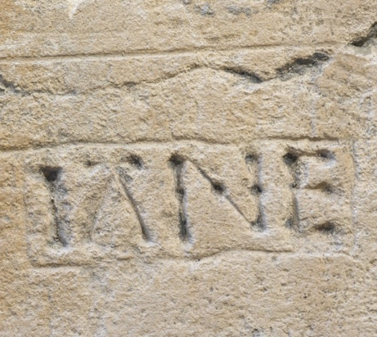 |  |  | 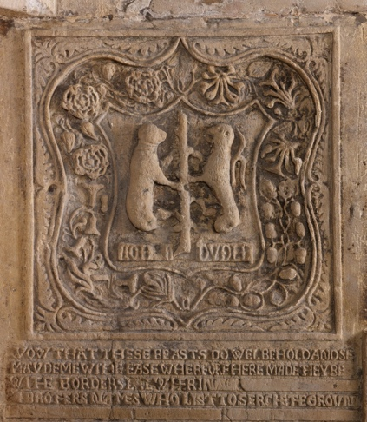
1. What is similar about them?
2. What is different about them?

8 | First Floor | Protestant Prisoners
1. What religion was Lady Jane Grey? __________________
2. Why did Mary I see Lady Jane Grey as a threat to her rule?

3. How did religion contribute to the conflict between Mary I and Lady Jane Grey?

4. How did Mary I respond to the threat posed by Lady Jane Grey?

5. Why did Mary I respond in this way? Use the themes of religion and power to support your answer.

9 | First Floor | Catholic Prisoners
Look closely at the Philip Howard (Earl of Arundel) carving.
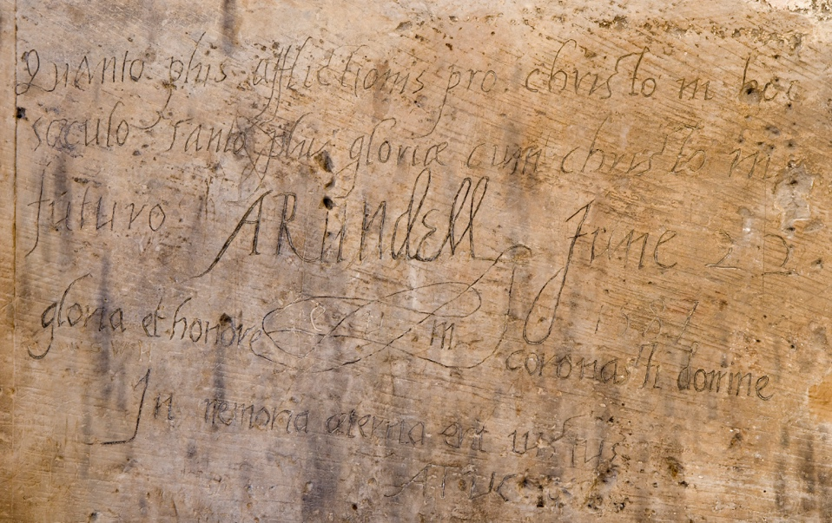
1. The carving is in Latin, but can you recognise any words?

2. What might the carving be about?

3. Read or listen to the translation of the carving. What do you think Philip Howard meant by these words?

10 | First Floor | Catholic Prisoners
1. What religion was Philip Howard? __________________
2. What role did religion have to play in Elizabeth I’s decision to imprison Philip Howard?

3. Was Philip Howard a direct or indirect threat to Elizabeth’s reign? Why?

4. Using the examples of Lady Jane Grey and Philip Howard, compare how Mary I and Elizabeth I dealt with religious threats. Include:
- the role of religion
- the threat to the monarch
- how the Tower of London was used
- what ultimately happened to each prisoner

Instructions
Use this student booklet alongside the interactive Religion, Power and Conflict virtual tour for KS3. To print as an A4 booklet:

- Go to File > Print.
- Select your printer and set it to:
Print on Both Sides (flip on short edge).
- In printer options or printer set up choose:
landscape and A4.
- Check for any scaling options and set them to: 100% or Actual Size. This may also need to be done in File > Options > Advanced > Print > Deselect: “Scale content for A4”
Answers (teacher can delete)
Building Features 2. Defence, prison, visitor attraction, home. 3. The Beauchamp Tower’s strong stone design and position within the inner defences, close to the River Thames, made it easy to guard prisoners, control access, and move high status captives securely, reinforcing Tudor authority.
Tudor Crime and Punishment 1. The Monarch (King/Queen) 2. Stealing, hurting, blasphemy, breaking sumptuary laws, treason. 3. Whipping, fines, stocks, prison, execution. 4. The building has lots of defensive features such as crenellations, arrow loops and turrets from when it was built in 1281.
Religious Rollercoaster 1. Henry VIII was Catholic (however, he started a more Protestant church in England as part of the Reformation). Edward VI was Protestant. Mary I was a strict Catholic. Elizabeth I was Protestant.
Prisoners’ graffiti 1. Common themes include religion (crosses), dates, names, symbols including flowers and skulls. 2. The crosses may be evidence of people’s religion, or that they were here due to religious or political reasons. 3. Names you might find include Thomas Peverell, Thomas Abel, Thomas Bawdewin, Charles Bailly, Jane, Dudley, Philip Howard, but there are many more.
Protestant Prisoners 1 1. Both feature names of people held at the Tower. They were probably made around a similar time. 2. The Dudley carving is very elaborate and might have been carved by an expert using special tools. It has symbols and a coat of arms and is near the fireplace. The Jane carving is very simple and plain and was likely carved by a prisoner.
Protestant Prisoners 2 1. Protestant. 2. Lady Jane Grey was a threat because she had been chosen by Edward VI to become queen, while Mary believed she was the rightful monarch. 3. Edward chose Lady Jane Grey because she was Protestant like him, whereas Mary was a strict Catholic. Mary offered Jane the chance to give up her faith and be spared, but Jane refused. 4. Mary I imprisoned Lady Jane Grey and her husband in the Tower of London and eventually had them both executed for treason. 5. Mary responded in this way to prevent Lady Jane Grey from gaining support from Protestant followers, which helped secure her power and allowed her to restore Catholicism in England.
Catholic Prisoners 1 1. Christo/Christ, Gloriea/Glory, Honore/Honour. 2. The carving is about the prisoner’s faith. 3. Philip Howard’s carving suggests he believed that the more pain he experienced in God’s name whilst he was alive, the more happiness (glory) he would get in heaven.
Catholic Prisoners 2 1. Catholic. 2. Elizabeth I imprisoned Philip Howard because he had secretly returned to the Catholic faith, which caused suspicion; she wanted him to conform to Protestantism and feared the influence of his religion. 3. Philip Howard was an indirect threat to Elizabeth’s reign because, although he was not a claimant to the throne, his status and Catholic faith meant others could rally around him and support plots or rebellions. 4. Mary I and Elizabeth I both used the Tower of London to deal with religious threats, but in different ways. Mary I saw Lady Jane Grey as a direct Protestant threat to her rule and had her imprisoned and executed. In contrast, Elizabeth I saw Philip Howard as an indirect Catholic threat, so she imprisoned him in the Tower to prevent rebellion, but he was not executed and died there of natural causes.


