Front cover
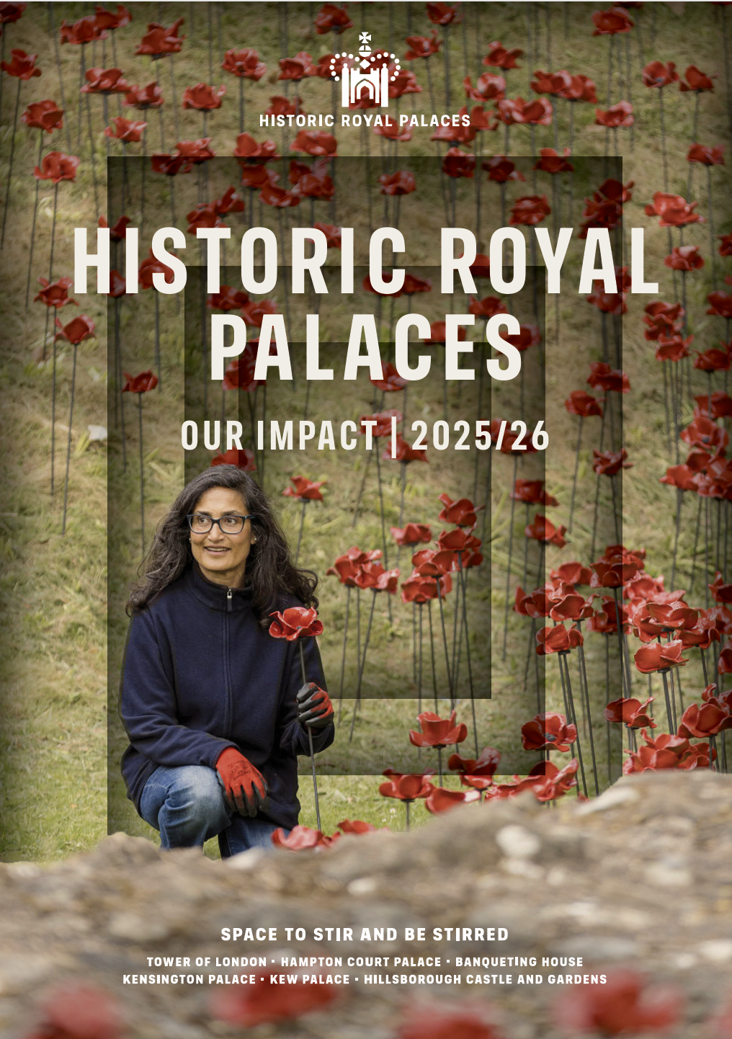

Historic Royal Palaces: Our Impact 2025/26

Contents

Palaces that mean more: An Introduction from our Chief Executive 3
A charity for everyone 5
A Year of Impact 6
Access for all 7
Better resources, greater accessibility 8
Telling stories, brick by brick 14
Made to be experienced 22
Custodians of the future 32
Spaces to belong 39
Palaces fit for the future 48
Built to last a thousand years 56
An unforgettable year 58
How we manage our money 59
With sincere thanks to those who make our work possible 59
Governance 60
Help give our palaces a future, for everyone 60

Palaces that mean more: An Introduction from our Chief Executive
At the close of the Western Balkans Summit at Hillsborough Castle and Gardens, a delegate said something that stayed with me: ‘We wouldn’t have come anywhere else. We came because of its history. It meant something for the talks.’ It was a reminder that the palaces can mean different things to many people, often in ways we could never fully predict.
Throughout 2025/26, we saw people finding connection, inspiration, comfort and curiosity within these extraordinary places. We saw it in relaxed openings that welcomed neurodivergent visitors into the palaces with fewer barriers. In the return of the ceramic poppies to the Tower of London, remembrance became a shared act of reflection and connection. And beyond our walls, in classrooms across the nation, where more than 3,000 nominations were submitted for our inaugural Inspiring History Teaching Awards.
Increasingly, we are thinking not only about how people come to the palaces, but how the palaces can go to them. Through outreach, digital storytelling, sensory learning, community partnerships, and immersive experiences, we are continuing to open up these inspiring spaces to new audiences in ways that feel more relevant, inclusive, and personal.
As a charity for everyone, our ambition is not simply to welcome more people through the gates, but to help more people see themselves in the stories we share.
There are challenges ahead. Overseas visitor numbers are currently in decline and many here in the UK are struggling with rising costs, but those pressures remind us to focus on the work that creates the greatest value for people and communities.
At their best, the palaces are not static historic sites, but places that continue to resonate in personal and unexpected ways.
No two people will find the same meaning within them. And that is part of their enduring power.

A charity for everyone
  - Our mission
We are the independent charity that loves and looks after six of the most wonderful palaces in the world.
The palaces are the setting for stories that shape us all, and we’re bringing those stories to people in ways that mean more to them.
We want everyone to find themselves in the spaces and stories we share.

A Year of Impact
Over 5.3m people welcomed to our sites
86% of visitors experience joy at our sites - Taken from our 2025/26 visitor survey
280,000 schoolchildren, teachers and home-educators reached through our education work
5.3% of our workforce in apprenticeship programmes
Our staff were trained to better support people with hidden disabilities
35% Our staff were trained to better support people with hidden disabilities
35% reduction in gas consumption since 2019. That’s enough energy to heat 360 UK homes
89 objects acquired for our collection
106m people connected with Historic Royal Palaces online

Access for all
  - Opening our palaces to the public
A palace can be many things. A place of ceremony, a classroom, a space to marvel at, a room where someone becomes a citizen of a new country. Everyone experiences the palaces differently, and that's what makes them so special
Each year, millions of people find their own way into our stories. We're working tirelessly to ensure that whoever you are, and however you come to us, there is something here that belongs to you.
The palaces aren't just places you visit. Sometimes, they're places where everything changes. At Hillsborough Castle this year, 20 citizenship ceremonies welcomed around 800 people into a new chapter of their lives.
Through our visitor offers, £1 tickets and access schemes, school visits, digital resources and outreach programmes, we’re sharing our palaces with people everywhere. The more people who engage with our stories, the richer these stories become

Facts and figures
233,000 £1 tickets sold
137,650 active blog users
740,900 podcast downloads

“The £1 scheme is a fabulous idea to make cultural visits affordable to historic sites." - Hillsborough Castle Visitor Survey Response

Better resources, greater accessibility
This year, we launched dedicated access guides and sensory maps at several of our sites. These free resources grew out of a meticulous, room-by-room process that began at Hampton Court Palace
Developed in-house by our Community Partnerships, Operations, Digital Engagement and Design teams, the guides were built from the ground up: every space assessed for steps, ramps, lifts, tight corners, lighting, crowding, noise and smell. They were then cross referenced with independent access reports and shaped through feedback sessions with disabled visitors to ensure they worked in practice
The guides are supported by videos on our website that provide an overview of the visitor experience, highlighting accessibility information. Available as physical booklets at ticket offices and palace entrances, and as digital downloads to print at home or save to a phone, these guides are living documents, updated as spaces change.
At Hampton Court Palace and Kew Palace, new Learning Sensory Bags support school groups with additional needs. Each bag is tied to a historical figure with connections to the palace and packed with tactile objects, along with trails and activity sheets designed for varying learning needs.
For learners who cannot visit our palaces due to profound and severe physical and learning disabilities, we have launched a new outreach programme that brings the palace stories into their schools through objects, resources and teacher training sessions

Facts and figures
We were shortlisted in the Visitor Accessibility category at the Museum & Heritage Awards 2026.

“I visited Kensington Palace as a solo visitor who is a wheelchair user on Wednesday morning this week, and just wanted to thank the staff… It is wonderful to get to see such a beautiful building, and to find it made so accessible with policies and strategies that are so well applied by the staff team. It is not always my experience by any means! I also very much appreciated the thorough accessibility information available on the website which I read before my visit." - Kensington Palace visitor feedback

“The whole goal is really to facilitate and support disabled people coming to our sites… giving them the agency and the decision-making power as to what is and isn’t for them." - JJ Leighton, Community Partnerships Producer

“The access videos are not something we’ll just complete and move on from. We’ll continue to improve and adapt them as we move forward." - Charlotte Gunnell, Digital Producer

Opening Banqueting House to new audiences
For more than 400 years, Banqueting House has witnessed some of Britain’s most dramatic moments, from the spectacle of Jacobean masques beneath Rubens’s painted ceiling to the execution of King Charles I. In 2026, the building entered a new chapter following a major conservation and accessibility project, making this historic space more accessible than ever before.
Over two years, and with the generous support of the Garfield Weston Foundation and The Wolfson Foundation, Historic Royal Palaces restored architectural features, installed a new sustainably sourced English oak floor, upgraded the building's environmental systems and introduced a passenger lift, offering step-free access to the Main Hall and Rubens’s masterpiece ceiling for the first time.
A commitment to doing things properly guided the project: materials chosen for their environmental credentials, systems upgraded for long-term efficiency, and access built in as a permanent feature rather than an afterthought.
A new chapter in access:
We opened our doors in March 2026 to group leaders of our Community Access Scheme, as well as wheelchair-user content creators and history influencers who were able to experience the building first hand, exploring what thoughtful conservation can make possible.
Through public open days, accessible events, and a new visitor experience launching in August 2026, the next chapter is only just beginning

“It was great to hear the historic royal palaces team talk about accessibility, not just how it's a big aim for them to make their historic sites more accessible but how in doing so it's actually taught them more about the buildings and their understanding of the history itself. Preserving history and accessibility are often framed as being two opposing goals but that doesn't have to be the case." - Sophie Butler's Instagram account @sophjbutler in reference to a gifted/ influencer event hosted at the location

Creating more inclusive experiences
The palaces in our care should be warm, welcoming and inclusive spaces for everyone. We are committed to removing barriers and creating experiences that help more people feel comfortable, represented and able to connect with the stories and spaces around them.
As part of this work, Historic Royal Palaces expanded its programme of relaxed openings and accessible experiences across its sites. Following two successful relaxed events for neurodivergent and learning-disabled children and families at the Tower of London, Kensington Palace hosted its first relaxed opening for neurodivergent and disabled young people and adults in November 2025.
The event featured reduced visitor numbers, adapted lighting and sound, accessible activities and neuro-inclusive staff training, helping create a calmer and more comfortable environment for visitors. The programme forms part of a wider commitment to improving accessibility across the palaces, including deaf-led tours and new in-depth access guides and videos for visitors with additional needs.

Facts and figures
1,103 people attended relaxed opening sessions at the Tower of London and Kensington Palace in 2025/26

What’s next?
Access guides and sensory maps are now live at Hampton Court Palace and Kensington Palace with the Tower of London, Banqueting House and Kew Palace to follow. As part of our commitment to bringing learning opportunities to those who are unable to visit our sites, we are working in partnership with Kings and Maudsley Bethlem Hospital Schools to develop a ward-based programme that will enrich the learning of children based there.

Telling stories, brick by brick
  - Caring for our palaces and collections
From delicate threads in 16th-century tapestries to 7,000 hand-cut bricks high above the Tudor kitchens, this year’s conservation work has spanned centuries.
Across the palaces, specialist teams cared for everything from royal dress and historic furniture to brickwork, oak gates and wall paintings, using traditional skills, careful research and minimal intervention to protect the integrity of each object and space. Our conservation work goes beyond preserving the places and objects of the past. We want to leave things more beautiful than we found them and uncover the human stories still hidden within our buildings and collections.
During renovation works to the Duke and Duchess of Teck’s apartments at Kensington Palace, conservators discovered a tin plate concealed behind the shutters, inscribed and dated 1867 by the tinsmith who fitted it more than 150 years ago. This year also saw the acquisition and conservation of a rare 18th century travelling spinning wheel, commissioned by Queen Charlotte, for permanent display at Kew Palace. This small but significant addition connects wider audiences to stories of craft, tradition and heritage through women’s lives. Moments like these remind us that the palaces bear the imprint of the people who built, repaired and lived within them, and that there is always more to discover, understand and protect.
“Preventive Conservation is so varied, I've had so many opportunities to learn and gain experience in all different parts of the job - cleaning from a scaffold, learning about pest management (even spiders!) and supervising filming or events in the palace.” – Sara Crouch, Apprentice Preventative Conservation Technician

Facts and figures
20 new 3D scans for the Royal Ceremonial Dress Collection in partnership with Google Arts & Culture
18 items in the collection sent on loan

Reconstructing Hampton Court Palace’s iconic kitchen chimneys
The skyline of Hampton Court Palace is one of its most recognisable features. Rising above the Tudor rooftops are 241 chimneys, each stack richly decorated and entirely unique. In the 16th-century, chimneys were a visible symbol of immense wealth and status, designed not only for function but to impress.
Centuries of wind, rain, frost and shifting ground have gradually taken their toll. When structural cracking and movement left the triple and quadruple chimney stacks above the Tudor Kitchens beyond repair, a major reconstruction project became necessary. Over the course of more than a year, 7,000 new cut-and-rubbed bricks were carefully produced and laid by hand, faithfully matching the original design. Each brick was individually shaped and hand-finished, creating the crisp decorative lines that define the palace skyline. Depending on its complexity, a single brick could take anywhere between 15 minutes and an hour to cut.
Where possible, one bricklayer worked on the same chimney shaft from bottom to top, laying every brick by hand. Even working to the same measurements and designs, each craftsperson leaves behind their own subtle marks and methods.
This project reflects our commitment to preserving and caring for these remarkable places. We do so not only to protect their history, but to ensure they continue to inspire, engage and enrich the lives of generations to come.

Facts and figures
1.97m people followed along with the chimney restoration on social media

A future for the Great Gatehouse
The Great Gatehouse has welcomed visitors to Hampton Court Palace for centuries. Built for Cardinal Wolsey and later transformed under Henry VIII, it remains one of the palace’s most iconic features. Essential conservation work completed this year will help protect it for generations to come.
The project involved carefully dismantling and rebuilding the west oriel window, carrying out repairs to the brickwork and stonework, replacing the lead roof, and undertaking sensitive conservation work on the 16th-century oak gates. Remarkably, the gates had not undergone major conservation since around 1880, when they were discovered being used as a workshop floor before being repaired and rehung.
One of the project’s most intricate tasks was the carving of two new ornamental finials for the gatehouse roof. Working from detailed drawings, stonemason Emma Sheridan first translated the designs into clay models before hand-carving the final pieces in stone. The finished finials now sit high above the gatehouse, continuing a tradition of craftsmanship that has shaped Hampton Court Palace for more than 500 years.
Facts and figures
Three hidden shoes, none of them a matching pair, were discovered by the team when the Great Gatehouse lead roof was removed. Old shoes in buildings were left for one of three reasons: builders' waste, a lucky charm for the next job, or a witch trap, placed near entrances to snare any evil spirit trying to gain entry.

From excavations to access at St Peter ad Vincula
The current Chapel of St Peter ad Vincula has stood at the heart of the Tower of London since 1519. A Royal Peculiar and Chapel Royal, it is the resting place of Anne Boleyn, Thomas More and Thomas Cromwell, and has served as a parish church for the Tower community ever since it was first built. Until recently, it was only reachable via a series of staircases.
Making it accessible to everyone required one of the most complex excavation projects Historic Royal Palaces has ever undertaken. Over 30 weeks, archaeologists sieved more than 60 cubic metres of material in the largest excavation within the Inner Ward since the 1970s.
Beneath the current Tudor structure, they uncovered the remains of at least five earlier buildings dating back before the Norman Conquest, including successive chapels built by Henry I, Henry III and Edward I. The discovery has completely transformed our understanding of how the chapel developed over time.
The excavation also revealed 23 articulated skeletons alongside remains associated with as many as 100 other individuals, dating from the 11th to the 16th centuries, and hundreds of small finds ranging from stained glass and burial shrouds to jewellery and funerary pots, only the third of their kind ever found in the UK.
Through analysis carried out over the coming years, these individuals will offer an unprecedented window into the lives of the Tower community, shaping the stories we tell about them for generations to come.
The project delivered a retractable stairlift installed with minimal archaeological impact, giving everyone access to one of the most significant spaces in the country.
With thanks to The Chapels Royal Foundation and to the Anthony & Elizabeth Mellows Charitable Settlement for generously supporting this project.

“By enabling access, we have ensured that families, friends and communities can be together in worship, celebration and grief where previously some would have been excluded. Working on this project over the last eight years has been the privilege of my life” - Alfred Hawkins, Curator of Historic Buildings

What’s next?
The Mantegna Gallery at Hampton Court Palace is undergoing an exciting transformation. Having been temporarily closed throughout 2026, the gallery will reopen in spring 2027 with an enhanced space and fresh new interpretation. This revitalisation will ensure a long-term home for Mantegna’s extraordinary Triumphs of Caesar paintings, ready to inspire visitors for years to come.

Made to be experienced
  - Enriching exhibitions, events and live programming
Designed to be vibrant, inclusive and wide-reaching, our live programming reflected our commitment to ensuring that everyone can find personal meaning within these extraordinary spaces.
Across exhibitions, festivals, performances and public events, the stories held within these historic places were brought to life for audiences of all ages and backgrounds. Some experiences were joyful and celebratory while others offered space for reflection, curiosity and conversation.
Facts and figures
371,127 visitors attended the ‘Dress Codes’ exhibition at Kensington Palace
8 Gun Salutes held at the Tower of London in 2025/26

Reimagining medieval life at The Tower of London
Following an important period of conservation and research, the Medieval Palace at the Tower of London reopened in May 2025 as a fully reimagined permanent display. It marks the most significant reinterpretation of these spaces in a decade and a new chapter in how Historic Royal Palaces brings the past to life.
Visitors are invited to step into the medieval worlds of Henry III and Eleanor of Provence, and Edward I and Eleanor of Castile. Throughout the rooms, richly decorated with textiles and wall paintings, soundscapes of crackling fires, Latin prayers, and 13th-century court music create a vivid sense of atmosphere and place.
Alongside stories of kings and queens, the display shines a light on the hundreds of people who made life in the Medieval Palace possible, from servants and surgeons to laundresses and bear-keepers. A 700-year old fish trap discovered in the Tower moat sits alongside new illustrations and interpretations exploring the daily realities of Medieval Palace life.
The project also brings greater visibility to the Tower’s medieval Jewish history, including a mikveh stone on loan from the Jewish Museum London. This rare surviving object, excavated not far from the Tower of London, helps tell the story of England’s medieval Jewish community and their expulsion from England in 1290.
Connections between the Tower and the communities around it continue through the display. A tapestry created in collaboration with Tower Hamlets community group Stitches in Time (an education and participatory arts charity) draws on medieval artistic traditions while reflecting on contemporary experiences of London and belonging.
Behind the scenes, the project was also an opportunity for planned conservation work. Floors and walls were restored, new lighting installed, and specialist conservators and artists worked throughout the site. Historic Royal Palaces also partnered with the Building Crafts College, helping ensure traditional heritage skills remain part of the future of conservation work.
The Medieval Palace re-presentation has been generously supported by Herbert & Ellen Kozlov, Graham & Joanna Barker and The Fishmongers’ Company & Charitable Trust.
“Our brief for this reinterpretation was very much to share the human stories of the people who lived and worked in these spaces. We have worked hard to be more inclusive and are proud that queens receive as much attention as kings; that servants have been brought into the narrative; and that we have been able to share some of the lesser-known global contexts of this history.” -Dr Charles Farris, Public History Lead

A celebration of pioneering princesses
In March 2026, Kensington Palace opened ‘The Last Princesses of Punjab’, a major new exhibition marking the 150th birthday of Princess Sophia Duleep Singh – Queen Victoria’s goddaughter, prominent suffragette and Punjabi princess.
While Sophia’s story sits at the heart of the exhibition, the display reaches far beyond a single life. It explores the six women connected across generations by empire, displacement, resistance and identity: Sophia’s grandmother Maharani Jind Kaur, imprisoned by the British after the fall of the Sikh Empire; her mother Bamba Muller, born into poverty in Egypt and navigating two very different worlds; and her sisters Catherine and Bamba, who each forged their own paths through a changing world. Overseeing it all is the presence of Queen Victoria, whose former childhood home has now become the setting for these stories to be shared.
Personal letters, rare family photographs and objects connected to the suffragette movement bring these women vividly into the present day. Contemporary responses from British South Asian people run throughout the exhibition, connecting past and present through reflections on identity, resistance, belonging and empire.
The exhibition invites visitors to encounter a more layered and expansive view of royal history, while creating space for new audiences to see their own stories reflected within the palaces.
‘The Last Princesses of Punjab’ has been generously supported by Khalsa Jatha British Isles, Gurdwara Aid, Guru Nanak Darbar (Gravesend), Gurdwara Sikh Sangat (London City) and RGB Direct. With thanks also to Davinder Toor and Peter Bance, who shared their unique collections and expertise so generously with us.
“The exhibition is an opportunity to centre powerful women in this chapter of our shared history, and we hope that visitors will be surprised, moved, and inspired by what they find” - Mishka Sinha, Exhibition Historian for ‘The Last Princesses of Punjab’

This exhibition reveals a story of courage, identity and resistance told through the lives of extraordinary women” - Polly Putnam, Curator of ‘The Last Princesses of Punjab’

We commissioned freelance illustrator Kushiaania to bring these inspiring women to life in the exhibition’s signature artwork:


“I want to learn as much as I can from these women. I want to hear about their stories. As I’ve gotten older, I’ve found I’m trying to connect more with my roots and this project has really helped me do that. I’ve been able to share it with the women in my family, which is quite special” - Kushiaania, illustrator

What’s next?
At Kensington Palace, the Queen’s State Apartments will reopen in April 2027 following a major conservation and re-presentation project. Restored interiors, newly opened spaces and immersive interpretation will explore the life and legacy of Mary II, bringing fresh attention to a queen whose story has often been overlooked. With thanks to Graham & Joanna Barker for their generous support of this project.
Meanwhile, the Tower of London will unveil a powerful new exhibition created in partnership with the Royal Armouries. Located within the White Tower, the display will explore the Tower’s darker history through authentic objects and people-focused storytelling, examining how tales of torture and execution have shaped its reputation across the centuries. With thanks to the Star Family Foundation, USA for generously supporting this work.

A summer of festivals, wellness and wonder
Our palaces have always been places to explore the past. But now they’re also places to breathe, to laugh, to somersault across a lawn, and to discover something completely unexpected. Across 2025/26, a growing programme of festivals and events opened up our sites to new audiences and offered everyone a reason to come back.
Feel Good at Hampton Court Palace
The Feel Good Festival, in partnership with The London House of Wellbeing, brought a new kind of energy to the grounds of Hampton Court Palace. A full weekend of breathwork, reflexology, meditation and journaling, with a pop-up wellness clinic offering professional health screenings covering everything from gut health and hormones to stress and tiredness. All of it set against the backdrop of one of England’s most spectacular royal gardens.

Serious nonsense at The Big Bahooey
Families and thrill-seekers came in their droves to The Big Bahooey. Hampton Court Palace's Great Fountain Garden was transformed into a riot of aerial cabaret, world-class street theatre, live shows, circus workshops and roaming creatures. In collaboration with Cirque Bijou, it was a May bank holiday weekend of some serious nonsense.
“I loved it. I thought it was great. The acrobat guys were amazing. I want to do that when I’m older! Young visitor to The Big Bahooey

Facts and figures
20,933 visitors joined in the silliness at The Big Bahooey

What’s next?
In July 2026, Hampton Court Palace will host the first-ever Rest is History Club Festival, a two-day celebration of live history led by Tom Holland and Dominic Sandbrook. The festival will bring together some of the world’s leading historians, including Mary Beard, Tracy Borman and Helen Castor, for eight headline shows across the weekend.
In August, the Tower of London will become home to ‘Imagining Animals’, a major two-week programme of dance, puppetry and music inspired by the creatures once housed in the Tower’s Royal Menagerie. Produced in partnership with communities and arts venues across Tower Hamlets, the programme will transform the historic site through performance, creativity and shared storytelling. We are grateful to Cockayne Grants for the Arts, a Donor Advised Fund, held at The Prism Charitable Trust for their support of ‘Imagining Animals’.
And as the year draws to a close, The Winter Palace at Hampton Court Palace will invite families into an immersive world of mythical creatures, live performance and large-scale installations woven throughout the palace’s historic rooms. Running from 28 November 2026 to 3 January 2027, the Christmas Beast Ball will sit alongside the much-loved Festive Fayre and ice rink.

Custodians of the future
  - Shaping the next generation of heritage lovers and professionals
The stories held within the palaces belong as much to the future as they do to the past. This year, we continued to find new ways to help young people connect with the palaces and their histories, whether by visiting in person or using our resources in their classrooms and communities.
Thousands of students of all ages, backgrounds and abilities visited the palaces across the year, while outreach programmes, online sessions and sensory resources helped bring these stories to schools and young people who may never otherwise have the opportunity to engage with them.
Facts and figures
206,000 education visits to our palaces in 2025/26
20,000 applications for the Access Fund and Travel Bursary
Our Access Fund for Schools and Travel Bursary Scheme have been fully funded by charitable donations.
“Over the next decade, we aim to reach every school in the UK, helping more young people understand the past and shape the future” - John Barnes, Chief Executive of Historic Royal Palace

A journey into Tudor life
The year is 1522. Henry VIII is on the move, and the gardens of Hampton Court Palace are preparing for his arrival.
In June 2025, the first-ever schools Tudor Festival invited students to step into the sights, sounds and spectacle of a royal progress. Across five days, schools, home learners and community groups encountered demonstration tents, live performances, Tudor games and costumed historical characters, creating an immersive experience of court life on the move.
Colour, music, performance and activity filled the gardens as young people experienced the bustle and energy of the Tudor world firsthand. The festival was fully booked, with travel subsidies available for eligible state schools to help ensure cost was never a barrier to taking part.

“It was fantastic - we loved the variety of activities the children could experience and it really deepened their understanding of Royal Progresses and the Tudors more broadly” - Teacher feedback

With thanks to Delancey Real Estate for their generous support of the Home Educators programme.

Inspiring teachers deserve to go down in history
Historic Royal Palaces’ inaugural Inspiring History Teaching Awards set out to find the teachers who make history matter in classrooms across the country.
From primary schools to further education and SEND settings, the awards recognised teachers who go beyond the curriculum to spark curiosity, confidence and imagination.
To ensure genuine national reach, the initiative was developed in collaboration with organisations across all four nations, including Cadw in Wales, Royal Collection Trust, the Palace of Holyroodhouse and the Historical Association of Northern Ireland.
Ten regional and national winners were announced in March 2026 following thousands of nominations submitted by pupils, parents and colleagues across the UK. Each winner received £500 for themselves and £500 for their school, alongside memberships to Historic Royal Palaces and the Historical Association.
The overall winner was announced at a ceremony at the Tower of London on 20 June 2026, judged by historian and broadcaster Lucy Worsley, alongside Greg Jenner, Sathnam Sanghera, Dan Jones, Shalina Patel, Katie Hunter and Michael Riley.

“Great history teaching doesn’t just tell students what happened – it helps them think, question and connect with the world around them” - Lucy Worsley, writer, broadcaster and Historic Royal Palaces ambassador
Our heartfelt thanks go to The Historical Association, our Associate Partner, and the Association of Independent Museums, whose support has helped ensure these awards reach classrooms nationwide.

Facts and figures
Over 3,000 inspiring teachers nominated

Learning on the job at the palaces
Launched in 2024, the Historic Royal Palaces Apprenticeship Programme offers non-traditional entry routes into the heritage sector. Apprentices work in roles spanning conservation, fundraising, legal, retail, digital production and more, gaining hands-on experience across our six remarkable sites.
The programme is built around a long-term commitment to diversity, inclusion and meaningful career development. Alongside accredited training, apprentices receive mentorship, pastoral support and opportunities designed to build confidence, skills and connections beyond their immediate roles.
This year’s cohort also took part in a five-day residential at Skern Lodge Outdoor Activity Centre in North Devon. Away from office desks and screens, apprentices spent the week surfing, raft-building, hiking the Hartland coastline, tackling high ropes and navigating unfamiliar places together.
The residential was designed to strengthen the qualities that matter throughout a career, including resilience, communication, teamwork and self-belief. Just as importantly, it created space for friendships, shared experiences and a stronger sense of belonging within the organisation.
With thanks to The Swire Charitable Trust and The Gosling Foundation for their support of our Apprenticeship Programme.

Facts and figures
19 new apprentices started building their careers in heritage in 2025/26

“What I love most about working at Historic Royal Palaces is its people-centred culture - everyone is so welcoming and friendly. Through my legal work, I’ve been incredibly lucky to be able to support teams across the organisation and contribute to exciting projects like the Festive Fayre at Hampton Court Palace and ‘The Last Princesses of Punjab’ exhibition at Kensington Palace” - Rutvi Shah, Solicitor Apprentice, Commercial Contracts
“What makes our Apprentice Programme at Historic Royal Palaces so special to me is seeing the real difference it makes to people’s confidence and futures. It’s not just about giving someone a job or work experience, it’s about helping them realise what they’re capable of. Dave Jones, Early Careers Manager

“Historic Royal Palaces is an amazingly unique organisation to work for. Coming in with little experience in heritage has been no barrier at all. I’ve felt genuinely supported from the start by both my team and the Early Careers Manager, Dave Jones. The programme itself has given me access to a wide range of professional learning opportunities, which has really accelerated both my skills and understanding of the working world. I’ve grown hugely in confidence, particularly in how I communicate, contribute ideas and take ownership of my work, it’s been an incredibly valuable experience both personally and professionally, and I don’t think there's anything quite like it. I look forward to what else is in store for me!” – Kate English, Corporate Planning Apprentice

What’s next?
We are continuing work on Tomorrow’s Tower, a once-in-a-generation programme that will transform how people experience, learn from, and connect with the Tower of London.
We have already completed the Medieval Palace transformation, and the next step will see the Tower’s biggest-ever investment in learning and community engagement. We will increase learning capacity by 250% and create new educational and community spaces.
Our fundraising campaign for Tomorrow’s Tower is already gathering significant momentum. Over £20 million has been donated and pledged, reflecting extraordinary belief in our vision for the future of the Tower of London. Continued support will help us realise this ambitious programme and secure the Tower’s legacy for centuries to come.
We are grateful for the unprecedented support we have received for Tomorrow's Tower from donors and partners including The Julia Rausing Trust, Garfield Weston Foundation, The National Lottery Heritage Fund, the Clore Duffield Foundation, the Sandys Trust, Charles & Nicky Manby, Star Family Foundation, USA, and Herbert & Ellen Kozlov, with fundraising ongoing.

Spaces to belong
  - Our part in community life
The palaces have always been places of gathering, story and belonging. This year, we’ve opened our doors to more people and found new ways for everyone to see themselves in these extraordinary spaces.
At Hillsborough Castle and Gardens, ‘Floral Threads: A Year in Bloom’ brought together participants from Choice Housing and Priesthill Methodist Tuesday Club to create a vibrant new textile display inspired by floral embroidery from garments designed for royal women, as featured in the castle’s ‘Royal Style in the Making’ exhibition. Working alongside textile artist Úna Hickey, participants explored appliqué, silk painting and embroidery techniques.
At Kensington Palace, British South Asian people contributed responses and reflections that helped shape ‘The Last Princesses of Punjab’, connecting contemporary perspectives with stories of identity, resistance and empire explored throughout the exhibition.
Through our Amazing Days Out community programme, children, young people and families facing significant challenges were welcomed into the palaces for days shaped around creativity, exploration and time together, including storytelling, object handling, arts activities and space to explore freely at their own pace.
Meanwhile, Historic Royal Palaces’ dementia-friendly programme marked its tenth year, continuing to offer thoughtful, person-centred experiences for people living with dementia and their companions across the sites.
Facts and figures
32,010 welcomed through our Community Access Scheme (CAS)
100% of our partners said CAS has a positive impact on their community group
55 Amazing Days Out delivered for children and families

“Our partnership plays an important role in bringing a sense of normality to families after the traumatic experiences they have been through. Thanks to your generosity, whenever they are at the palaces, I see them able to forget their difficulties, even if just for a moment, and feel that there is hope and new possibilities ahead. Furthermore, I can see that they feel special. During our last visit, the children were running around excitedly, while the mothers were laughing, having picnics, and enjoying each other’s company. I even found myself stepping away from daily pressures and simply enjoying the beautiful setting and the joy of the families” - Feedback from a community partner

The Tower Remembers
In May 2025, nearly 30,000 ceramic poppies returned to the Tower of London to mark the 80th anniversary of the end of the Second World War. Originally created by artist Paul Cummins for the landmark 2014 installation ‘Blood Swept Lands and Seas of Red’, the poppies once again filled the Tower with a powerful act of remembrance.
Created by Historic Royal Palaces and designed by Tom Piper, the installation saw cascades of blood-red flowers flowing down the White Tower, gathering in a crater at the heart of the fortress and emerging beneath St Thomas’s Tower.
To accompany the display, Historic Royal Palaces commissioned a new poem from Poet Laureate Simon Armitage. The poem reflects on the enduring symbolism of the poppy at a moment when the Second World War is beginning to pass beyond living memory.
150 volunteers from across Historic Royal Palaces and our Community Access Scheme gave around 700 hours of their time, and worked alongside professional teams and Yeoman Warders to help install the poppies.
Community groups involved included Grenfell Health and Wellbeing Service, Golden Years, Healthprom, Lewisham College, A Little History of the Sikhs and Waterloo Uncovered.
Thank you to all our volunteers
In total, more than 1,000 volunteers gave over 48,000 hours in 2025/26, supporting roles across our palaces – including ‘The Tower Remembers’. Their time and care help us fulfil our charitable ambition: to make the palaces mean more to more people.
“As the Second World War begins to pass out of living memory, it’s more important than ever that we come together to remember, share stories of the past and to each reflect on the lasting legacy of conflict. We hope that this display will offer many people the opportunity to do that. Brigadier Andrew Jackson, Governor of the Tower of London

Supporting veterans and military families
The Yeoman Warders involved in the installation have served long careers in the Armed Forces, bringing a deeply personal connection to the act of remembrance.
Reflecting the Tower’s longstanding ties to the military community, Historic Royal Palaces also worked closely with serving personnel, veterans and military families throughout the project.
These events ranged from hosting small peer support groups to large Amazing Days Out for children and families, provided the guests time to explore ‘The Tower Remembers’ at their own pace. For many participants, these experiences created space not only for remembrance but also for reflection, connection, and shared understanding.
“The opening of ‘The Tower Remembers’ and the commemoration of the end of World War II was a real moment of living history for me. A connection not just with the veterans present but also to the long history of the Tower” -Lisa Burger, Historic Royal Palaces Trustee

In October, we welcomed 489 people, through six events, delivered in partnership with SSAFA, Combat Stress, King's Centre for Military Health Research, Naval Children's Charity, Naval Families Federation, Aggies, The Not Forgotten and Scotty’s Little Soldiers.

“This was such a special day for our families. For many of our members, Remembrance can be a difficult time, and events like this help them to feel connected to both the military community and to others who understand what they’re going through. We’re so grateful to Historic Royal Palaces for this incredible experience and for helping us to create moments of togetherness and reflection for our families” - Rachel Scott, Head of Service, Scotty’s Little Soldiers

Opening the Stennett Studio
The Royal Ceremonial Dress Collection holds more than 10,000 garments spanning centuries of royal history, from Tudor court dress to pieces worn by Diana, Princess of Wales. Through the Stennett Legacy Project, we’re able to bring this remarkable collection to wider audiences.
The project’s second phase saw the creation of the new Stennett Studio at Hampton Court Palace, a space designed to support access to the collection through conservation, filming, learning and community engagement.
Pilot sessions welcomed participants from the Dementia Friendly Programme and the Community Access Scheme into the studio for object handling experiences centred around touch, memory and conversation. Sessions began with tea, biscuits and time to chat together before participants explored selected garments and historic objects up close.
Many participants spoke about the emotional impact of handling pieces firsthand and the memories and stories they prompted. The success of the pilot has already inspired wider collections-based activities across the palaces, including wellbeing and object handling sessions at Kensington Palace and Kew Palace.
This important project has been made possible through the generous support of the late Michael Stennett (1946–2020), one of the world’s leading theatre and opera costume designers. We are proud to open the Stennett Studio in his name, enabling us to share the collection he loved in new and inspiring ways, creating meaningful experiences for more people than ever before.
“I’d never seen or touched authentic, over 100-year-old clothing that close up before” - Community group participant, Kew Royal Ceremonial Dress Collection visit

Leading dementia-friendly heritage
For nearly a decade, Historic Royal Palaces has been creating welcoming, person- centred experiences for people living with dementia and their companions.
In 2025/26, sessions ranged from sensory storytelling, creative workshops, wellbeing walks and object handling – all inspired by the stories at Hampton Court Palace and Kew Palace. Sessions aim to encourage curiosity, conversation and connection, helping participants feel a sense of belonging.
The programme expanded offsite, as the Community Partnerships team delivered outreach sessions at Memory Cafés and community centres local to the Tower of London and Kensington Palace.
We are committed to making our palaces dementia-friendly with many of our staff and volunteers Dementia Friends and proud members of Dementia Friendly Richmond. We champion best practice within the UK heritage sector, as leaders of the Dementia Friendly Heritage Network.

Facts and figures
317 people welcomed through 15 dementia-friendly sessions at Hampton Court Palace

Palaces fit for the future
  - Our commitment to sustainability, biodiversity and climate action
2025/26 has been a year of strong progress on our Sustainability Action Plan, with the foundations we’ve laid starting to deliver tangible results.
From operational improvements and staff-led behaviour change to biodiversity research and sustainable innovation within historic environments, sustainability is increasingly becoming part of everyday decision-making across the palaces.
We’re also investing in longer term solutions. This year saw the completion of the Banqueting House reservicing project, which introduced air source heat pumps, upgrades to the district heat network and improvements to building management systems. Alongside creating a more stable environment for the Rubens ceiling and improving accessibility, the project will deliver lasting sustainability benefits for generations to come.

Reducing emissions across the palaces
Our total carbon emissions for 2025/26 were 3,298 tonnes of CO2e – a 28% decrease compared to our 2019 baseline. We also achieved a decrease of 10% vs. 2024/25 – the largest year-on-year drop since COVID-19. Emissions from heating and electricity (Scopes 1 & 2) have fallen by 39%.
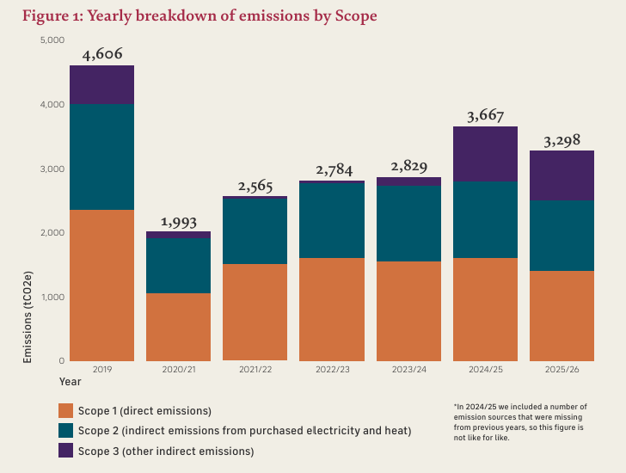

Championing sustainable travel
This year, our staff sustainability network partnered with Good Journey to encourage more sustainable travel to Hampton Court Palace and Hillsborough Castle and Gardens. The initiative helps visitors find low-carbon transport options, building on existing offers with TfL and South Western Railway, and introducing a new 20% discount for visitors arriving at Hillsborough on Translink bus services. By making greener journeys easier and more affordable, we're helping reduce the emissions associated with travel to our sites.
Figure 2 shows the main sources of our emissions, with gas heating systems across our sites continuing to account for the largest share. However, 2025/26 saw emissions from gas heating fall by 13% compared with the previous year – a saving of more than 200 tonnes of carbon. Achievements like this are only possible through the combined efforts of colleagues across the organisation. Better management of heating systems, alongside increased awareness, engagement and everyday actions by staff, has played an important role in reducing our energy use and carbon emissions.
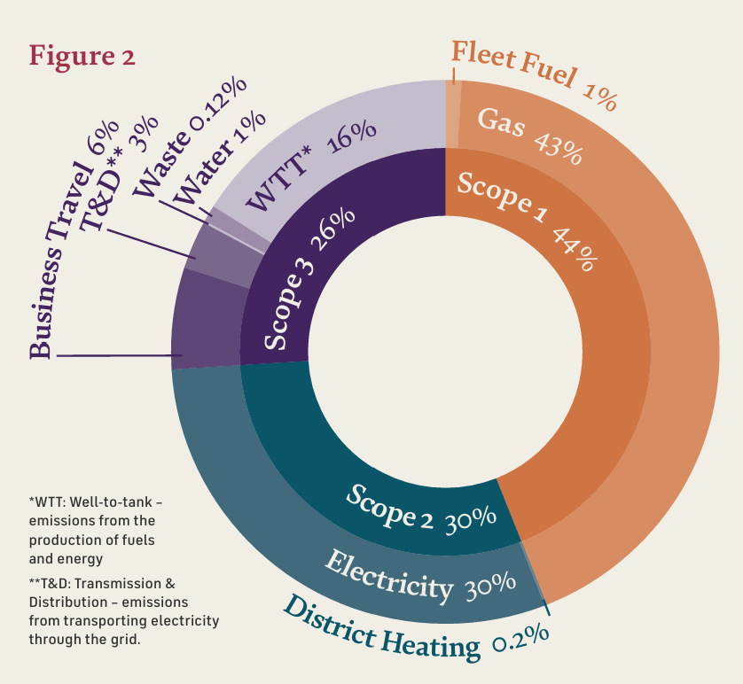

A royal seal against heat loss
Over the past few years, we’ve installed heritage approved secondary glazing across many historic buildings. Designed to improve heat retention while protecting significant windows and historic fabric, these interventions are helping us reduce energy use without compromising conservation standards. Recent installations in the Curators' Offices at Hampton Court Palace are almost invisible yet have reduced energy consumption by 17%.

Greener power for our palaces
Our London sites are now supplied through electricity tariffs backed by renewable energy certificates, meaning 88% of the electricity we purchase comes from renewable sources. Figure 3 shows our emissions from purchased electricity using this renewable electricity accounting method.
Table 1
Scope | Sum of Emissions (tCO2e)
1 | 1,443
2 | 123
3 | 605

Facts and figures
Our market based emissions were 2,171 tCO2e
Since 2019, we’ve reduced our gas use by over 4 GWh – enough energy to cook around 5 million pans of pasta.

Understanding the habitats and wildlife in our care
Working with ecology specialists, the Ecology Co-op, we carried out detailed biodiversity surveys across Hampton Court Palace, the Tower of London, Kensington Palace and Hillsborough Castle and Gardens.
The surveys mapped habitats, recorded species, assessed soil and water health and digitised historic wildlife records to help identify longer-term trends. Across the four sites, the surveys categorised 40 different habitat types, including eight UK Priority Habitats. Among them: 127 hectares of lowland dry acid grassland at Home Park, supporting a unique mix of specialised plants, pollinators and ground-nesting birds.
We also monitored the new moat scheme prototype at the Tower of London, where early results are encouraging. The new wetland spaces are already being colonised by aquatic insects, including seven species of water beetle and seven species of dragonfly, some of which are nationally scarce. This work gives us a much stronger picture of nature across our sites and will directly shape our biodiversity programme going forward.

Facts and figures
9 bat species across our sites
63 bird species at Hillsborough Castle and Gardens
97 moth species at Hampton Court Palace and Home Park
324 invertebrate species at the Tower of London
8 species of butterfly at Kensington Palace
39 species breed at Hampton Court Palace and Home Park

“By understanding the nature we care for today, we can take meaningful steps towards acting for the future and help biodiversity to flourish at our historic sites for everyone to enjoy. Rebekah Baker, Biodiversity & Sustainability Manager

Reimagining the Great Fountain Garden
At Hampton Court Palace, the Great Fountain Garden is undergoing an ambitious long term transformation led by celebrated garden designer Ann-Marie Powell.
Two trial beds were planted in early 2026, providing a test ground for new approaches to management, pollinator and wildlife monitoring and improvements in soil carbon. The completed scheme will eventually include 32 new planting beds featuring nearly 300 species, combining sustainable horticulture with the historic grandeur of one of the palace's most iconic landscapes.

What’s next?
We’re really proud of the progress we’ve made this year, and the strong platform it has given us for what comes next. As climate change and nature loss in the UK accelerate, we have an opportunity to build on this momentum, reducing our impact, strengthening our resilience and adapting our palaces, green spaces and operations for the future.
In 2026, we will deliver the first projects in our decarbonisation programme, aiming to remove 90% of emissions from our heating systems by 2035.
We will also be developing our plan for nature: carrying out new surveys, trialling technologies to monitor species and restoring habitats across our sites.
And we will be talking more to visitors, school groups and communities about what we are doing, inviting them to engage with the climate challenges ahead and test solutions alongside us. We want our palaces and landscapes to become living examples of how heritage spaces can support climate resilience and nature recovery.

Built to last a thousand years
  - Closing thoughts from our Chair
It was a particularly strong year for the six Historic Royal Palaces, and a particularly impactful one too. We welcomed 5.3 million people, including 206,000 on educational visits, reaffirming the enduring power of the palaces to inspire curiosity and a shared sense of heritage.
We have continued to invest, more heavily than ever, in the future of our historic sites, with major conservation projects across the whole portfolio. Caring for some of the most important heritage buildings in the country is never a simple task, but we take it on with pride.
We have expanded our charitable impact through education, community partnerships and outreach, opening up what we do to more people and ensuring that everyone has the chance to enjoy and benefit from it.
Like many heritage organisations, we rely on a great network of people. Our staff and volunteers, of course, but also our Trustees, members and supporters, whose commitment sustains our mission.
It has been a wonderfully strong year for donor support, from some of the great foundations and philanthropists, and we thank them from the bottom of our hearts.
But there is still more to do if we are to realise our ambitions, expand our charitable impact and grow our educational capacity for the future.
We’re fortunate to care for some of the most famous sites in the United Kingdom. It is both a privilege and a responsibility. Our aim is that the fabric and impact of the palaces will be as great in a thousand years as they are today.
Sir Nicholas Coleridge, CBE DL, Chair

An unforgettable year

The Valasse Cross comes to the Tower
A rare example of medieval royal goldsmiths' work associated with Empress Matilda, travelled from the Musée des Antiquités (Rouen Métropole Normandie) in France to St John's Chapel at the Tower of London on special loan. The loan was made possible thanks to the generous support of The Syder Foundation.

The Tower of London River Tour took to the Thames
Visitors stepped aboard Silver Raven, the UK’s first electric tour boat, for a 40-minute Thames cruise featuring live stories by Tracy Borman and Martha Howe-Douglas, co-creator of BBC’s ‘Ghosts’

Unheard Voices returned to Hampton Court Palace
A new season of performances brought overlooked Tudor and Georgian stories to life, exploring figures including John Blanke, Dido Elizabeth Belle and Michael Shen Fu-Tsung.

SIX the Musical came to Hampton Court Palace
The Tower of London River Tour took to the Thames Visitors stepped aboard Silver Raven, the UK’s first electric tour boat, for a 40-minute Thames cruise featuring live stories by Tracy Borman and Martha Howe-Douglas, co-creator of BBC’s ‘Ghosts’.

Work Skills Workshops launched at Kensington Palace
Students aged 14–19 took part in new Work Skills Workshops at Kensington Palace, supporting young people with learning disabilities and SEMH challenges through heritage. With thanks to the John Lyon’s Charity for supporting this work.

Hillsborough Castle hosted international leaders
Foreign Secretary Yvette Cooper welcomed Western Balkans Foreign Ministers to Hillsborough Castle, resulting in a landmark Joint Declaration on Good Neighbourly Relations and a shared commitment to gender equality.

Cameras rolled across the palaces once again
58 productions were filmed on site across more than 217 days throughout 2025/26.

Wordless Stories brought history to life online
With support from The Lord Leonard and Lady Estelle Wolfson Foundation we launched Elizabeth Tudor, the first in our new Wordless Stories series, helping young people connect with history through illustration. Now freely available to schools across the UK.

Beano Mischief arrived at the Tower of London
Dennis, Gnasher and the Beanotown crew transformed the Tower into an interactive comic-book quest, with families helping fix a broken time machine while spotting costumed characters along the way.

Ceremonial events and royal visits
Historic Royal Palaces welcomed 11 Second World War veterans to the Tower to mark the 80th anniversary of the end of the war. Her Majesty The Queen also visited to plant a poppy.

Winnie the Pooh brought summer magic to Hillsborough Castle and Gardens
Disney teamed up with Historic Royal Palaces for a family-friendly Winnie the Pooh Hunny Hunt trail across 100 acres.

HRH The Princess Royal opened the new Clore Learning Centre
The fully accessible learning space at Kensington Palace will welcome schools, families and community groups through creative, hands- on experiences.

Global leaders gathered for the Sustainable Markets Initiative Summit
The summit sparked new partnerships across clean energy, AI, hospitality and sustainable technology, bringing together breakthrough ideas shaping the future of sustainable growth.

How we manage our money
  - Our 2025/26 financial summary
We are a charity whose work is made possible thanks to income generated through admissions, commercial activities, and the generosity of our donors, patrons, members, and sponsors.
Every pound we earn, raise, and receive helps us care for six extraordinary palaces, share their stories with millions of people, and safeguard these remarkable places for future generations. In 2025/26, we invested in vital conservation work, inspiring learning programmes, memorable visitor experiences, and major capital projects, while continuing to extend our reach both onsite and online.
Looking ahead, we will continue to invest in our charitable mission and key projects, including Tomorrow’s Tower, our most ambitious fundraising campaign to date. At the same time, we remain focused on maintaining financial resilience in a challenging environment, with lower levels of international tourism and visitor demand.
The summary below shows where our income came from and how it was used to deliver public benefit in 2025/26.
For full details, please see our Annual Report and Accounts on our website.

Total income
- Donations, grants and membership – 11%
- Admissions – 59%
- Commercial Income – 24%
- Investments and other income – 6%

How income was used in 2025/26
- Caring for our palaces, collections and gardens – 28%
- Interpretation and education – 14%
- Opening the palaces to the public – 21%
- Future project investment – 15%
- Organisational development and income generation – 21%
- Sustainability – 1%

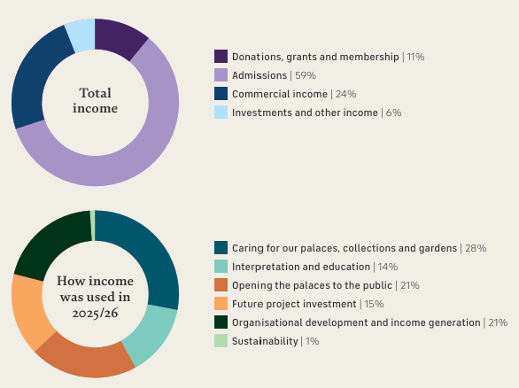

With sincere thanks to those who make our work possible
  - We couldn’t do it without you
We’re incredibly grateful to all those who support our work. As an independent charity, Historic Royal Palaces receives no regular funding from the Government. Everything we do is made possible by our visitors, members, donors, legacy pledgers and patrons. Your generous support helps us care for six extraordinary places and bring their stories to life for everyone, now and for the future.
We would especially like to thank the following donors and patrons, as well as those who have chosen to remain anonymous.

  - King’s Presence Chamber
  - Corporate Members
  - Corporate Sponsors and Donors
  - In-kind support
  - Ambassadors
  - Patrons
  - Campaign Board
  - Historic Royal Palaces, Inc. Board of Directors
  - Historic Royal Palaces, Inc. Patrons
  - Platinum Key Holders
  - The Foyle Foundation
  - Mrs Aud Jebsen Charles & Nicky Manby
  - The Star Family Foundation
  - USA Gold Key Holders
  - Bloomberg L.P.
  - City of London Corporation
  - J Paul Getty Jnr Charitable Trust
  - The Hobson Charity
  - Marsh
  - Mitsubishi Electric Europe B.V.
  - The Eranda Rothschild Foundation
  - Silver Key Holders
  - The Art Fund
  - Graham & Joanna Barker MBE
  - Blavatnik Family Foundation
  - Boundless by CSMA
  - The Bradbury Foundation
  - Bruce & Jane Carnegie-Brown
  - The BGS Cayzer Charitable Trust
  - The Clothworkers’ Foundation
  - Coates & Seely
  - The Worshipful Company of Drapers
  - William & Olga Fall
  - John Harding MBE
  - Herbert & Ellen Kozlov
  - John Lyon’s Charity
  - Charles Mackay CBE & Annmarie
  - Mackay Serrie & Ian Meakins
  - The Anthony and Elizabeth Mellows Charitable Settlement
  - The Rothermere Foundation
  - Mr & Mrs Peter Smedvig
  - Robert & Patricia Swannell
  - Swire Charitable Trust
  - Michael Uren Foundation
  - The Charles Wolfson Charitable Trust
  - The Lord Leonard and Lady Estelle Wolfson Foundation
  - World Monuments Fund
  - Bronze Key Holders
  - The Apollo Foundatio
  - Backstage Trust
  - Ian Barlow DL & Judy Barlow
  - Benefact Group
  - Kate Birch & Dominic Christian
  - Devon & Yvonne
  - Bruce Duke of Buccleuch & Queensberry, K.T., and the Trustees of the Buccleuch Chattels Trust
  - Constance Cincotta
  - Dr Martin & Dani Clarke
  - The Clasper Family
  - The John S Cohen Foundation
  - Susan Cook
  - Richard & Lucinda Cormack
  - David Cruickshank
  - Professor Mallory Factor KCNG & Elizabeth Factor Esq.
  - The Fishmongers’ Company
  - Marc Fitch Fund
  - Monica Gerard-Sharp
  - The Getty Foundation
  - Alderman Alison Gowman CBE
  - The Charles Hayward Foundation
  - Peggy Hui
  - Wol & Kerry Kolade
  - Dani Lachowicz
  - Jonathan B. Lewis
  - The Mallinckrodt Foundation
  - Donna Ockenden Limited
  - Joseph & Susan Power
  - Matthew & Erica Richardson
  - Mr & Mrs P Rowland
  - Dr & Mrs Allen Sanginés-Krause
  - The Schroder Foundation
  - Nick Segal & Genevieve Muinzer
  - Smurfit Westrock Foundation
  - The Syder Foundation
  - Richard & Harriet Taylor
  - M. Louise Wilson FRSA
  - The William Brake Foundation
  - The KT Wong Foundation
  - WRA Charitable Trust
  - Honorary Members
  - Michael Day CVO
  - Angela Heylin OBE LVO
  - Corporate Members
  - Bloomberg L.P.
  - Boundless by CSMA
  - Convex Insurance
  - John Lewis Partnership
  - Lazard
  - Marsh
  - Mitsubishi Electric Europe B.V.
  - Sotheby's
  - Syracuse University London
  - The Comets, Metropolitan Police Sports and Social Association
  - The Mitre Hotel, Hampton Court
  - The Royal Mint
  - Walpole
  - Corporate Sponsors and Donors
  - 3i
  - Avis Charles Associates
  - Delancey Real Estate
  - Garrard
  - Gurdwara Aid
  - Gurdwara Sikh Sangat (London City)
  - Guru Nanak Darbar, Gravesend Khalsa Jatha British Isles
  - Mixergy Limited
  - Mitsubishi Electric Europe B.V.
  - Optio Group
  - RGB Direct
  - Royal Salute
  - In-kind support
  - Coates & Seely
  - Ambassadors
  - Professor Sir David Cannadine
  - FBA FRSL FSA FRHistS FRSA
  - William Fall
  - Sir Rupert Gavin
  - Charles Mackay CBE
  - Dr Lucy Worsley OBE
  - Robert Swannell CBE A
  - Patrons
  - Council Chamber
  - Susan Cook
  - John Harding MBE
  - Serrie & Ian Meakins
  - Donna Ockenden Limited
  - Mr & Mrs P Rowland
  - Great Watching Chamber
  - Gary & Andree Allsopp
  - Nicola Andrews
  - Kate Birch & Dominic Christian
  - Peter & Diana Butler
  - Dr Martin & Dani Clarke
  - Mr & Mrs Anthony Hall
  - Suzanne Marriott
  - Mrs Jane E Miller
  - Elizabeth Sallis
  - Sarah Selkirk
  - Phil & Caroline Swallow
  - WRA Charitable Trust
  - Great Hall
  - Annabel Asprey
  - Andrew Hine
  - Lucinda Holmes
  - Geoff Low
  - Valerie & Philip Marsden MBE
  - Nick Segal & Genevieve Muinzer
  - Betsy & Rob Pitts
  - Mr & Mrs Kevin Smith
  - Nicholas & Amanda Wachsmuth
  - Heavens
  - Courtyards & Cloisters
  - Barry Adamson
  - Steve & Claire Almond
  - E & S Andrews-Fisher
  - Mark & Priscilla Austen
  - Ian Barlow DL & Judy Barlow
  - John Barnes OBE
  - James Bicknel
  - Dr & Mrs Stuart Blackie
  - Marie-Louise Bradley
  - Margaret Bremridge
  - Mrs Basia Briggs
  - Jennifer Pearl Cate
  - Joanne Chamberlain
  - Chloe Cooper
  - Anthony Dinkin KC
  - Charlotte Fletcher
  - Anupam Ganguli
  - Charles & Dawn Garland
  - Mr & Mrs P. Geddes
  - Irene Greatorex
  - Mrs Helen Haigh
  - Professor Julie Hastings
  - Anne Herd
  - Christian Hill
  - Jacqueline Isard
  - Julia Kirkham
  - Mr & Mrs Alan Lovell
  - Malcolm Lowe
  - James McDonald
  - Allyson & Conor McKimm
  - The Melville Charitable Trust
  - Mrs Diana Midmer
  - Mark & Jude Mladek
  - Antonia Newman
  - Richard Oldfield
  - Lady June Powell
  - Mrs Lorna Robson
  - Dean Rowel
  - Dr Maria Serrano
  - Carole Souter CBE
  - Bill Toner
  - M. Louise Wilson FRSA
  - Honorary Patrons
  - Todd Longstaffe-Gowan
  - Alison Weir
  - And those that wish to remain anonymous
  - Campaign Board
  - Jonathan Bewes (Chair)
  - John Barnes OBE
  - Alison Bishop
  - Elizabeth Campbell
  - David Cruickshank
  - Professor Mallory
  - Factor KCNG
  - Dame Tristia Harrison DBE
  - Lucinda Holmes
  - Carol Leonard
  - General Sir Gordon Messenger, KCB DSO* OBE DL
  - Rak Patel
  - Richard Taylor
  - Trelawny Williams
  - M. Louise Wilson FRSA
  - Historic Royal Palaces, Inc. Board of Directors Herbert
  - F. Kozlov (Chair)
  - Monica Gerard-Sharp (Vice Chair)
  - Professor Sir David Cannadine FBA FRSL FSA FRHistS FRSA
  - Ji Young Choi
  - James C. McCarroll
  - Genevieve Muinzer
  - Antonia Newman (Ex-officio)
  - Erica Richardson
  - Historic Royal Palaces, Inc. Patrons
  - Diamond
  - Jonathan B. Lewis
  - Sapphire
  - Michael J. Brown
  - Ji Young Choi
  - Deborah Dorshimer
  - Bill & Kim Galvin
  - Betty & Douglas Kruse
  - William & Serena Lese
  - Bethany & Robert B. Millard Foundation
  - Natalie Pray MBE
  - Ruby
  - Ramesh Bhimsingh
  - James Gordy
  - Wendy & David Hashmall
  - Christopher S. Moore
  - Brian Abel Ragen
  - George & Patti White
  - Christine Wong
  - And those that wish to remain anonymous

Governance
Our governance structure is robust in ensuring delivery of our strategy, operational plans, and compliance with our policies, but also agile enough to help us meet emerging challenges and make the most of new opportunities.
Non-executive: Oversight of strategy, policy, plans and compliance
Board of Trustees
Sir Nicholas Coleridge CBE DL (Chair)
Jonathan Bewes
Lisa Burger CBE
James Chalmers
Camilla Finlay
Tom Harris
Caroline Hope (from 9 January 2026)
Sarah Jenkins (until 30 September 2025)
Dan Jones
Tim Knox CVO FSA
General Sir Gordon Messenger KCB DSO* OBE DL
Dame Caroline Michel DBE FRSA
John Mothersole (from 1 October 2025)
Dr Jo Twist OBE (until 30 September 2025)
“Whenever I visit one of our sites, I am reminded of the extraordinary history that is connected with them. The Tower of London is outstanding. Our palaces are our greatest assets and we must ensure that they remain so”- James Chalmers, Historic Royal Palaces Trustee

Standing committees
- Audit, Risk and Assurance
- People
- Nominations and Governance
- Finance and Investment
We also have working groups focused on our charitable objectives and major projects

Executive: Development and delivery of strategy, policy and organisational plans
Chief Executive
Executive Team

Help give our palaces a future, for everyone
  - Our work is only made possible by people like you
We’re on a mission to help our palaces mean more to more people, while protecting them for generations to come and we’d love you to join us. Whether you're passionate about conservation, education or community events, there are lots of ways you can offer your support.
How to get involved:

Become a member
Enjoy unlimited entry, exclusive events and behind-the-scenes content, all while helping us care for these extraordinary places.

Make a donation
Every gift, big or small, helps us protect these remarkable places and share them with more people.

Leave a gift in your will
A legacy gift helps ensure these palaces – and the stories they hold – will be here for generations to come. It’s a lasting way to support the things you care about most.

Volunteer with us
Looking for a meaningful way to give your time, develop new skills, and connect more deeply with the stories that shape our past and future? Then consider becoming a volunteer and help to continue the fascinating stories of our palaces.

Become a patron
Becoming a patron is one of the most meaningful and fun ways to get involved with our work. Not only will you enjoy a close relationship with the charity, but also exclusive experiences and privileged access to the areas of the palaces not open to the public.

Partner with us
From corporate sponsorship to charitable partnerships, we work with organisations of all sizes to create purposeful relationships that make an impact.

For further information on how you can be part of Historic Royal Palaces, please contact our Development team at development@hrp.org.uk

Back cover

Contact us
Email: info@hrp.org.uk
Tel: 0333 320 6000

Follow us
Facebook: Historic Royal Palaces
Instagram: @historicroyalpalaces
X: @HRP_palaces
TikTok: @historic.royal.palaces

Acknowledgements
Text © Historic Royal Palaces 2026
Unless otherwise indicated, all images are © Historic Royal Palaces
This annual review was designed and produced by Historic Royal Palaces.

All rights reserved. No part of this publication may be reproduced, transmitted or stored in an information retrieval system in any form or by any means, electronic or mechanical, including photocopying and recording, without prior written permission from Historic Royal Palaces.

Historic Royal Palaces is a Registered Charity (No 1068852)

